**Module Name:** Login Page - Functional & UI Test Cases

**Test Case ID:** st_01

**Webpage URL:** https://www.instagram.com

### **Scenario ID: 1a**

**Scenario:** Sign up with valid credentials  
**Test Steps:**

1. Click on Sign Up
2. Enter Email
3. Enter Full Name
4. Enter Username
5. Enter Password
6. Click on Sign Up

**Screenshots:  
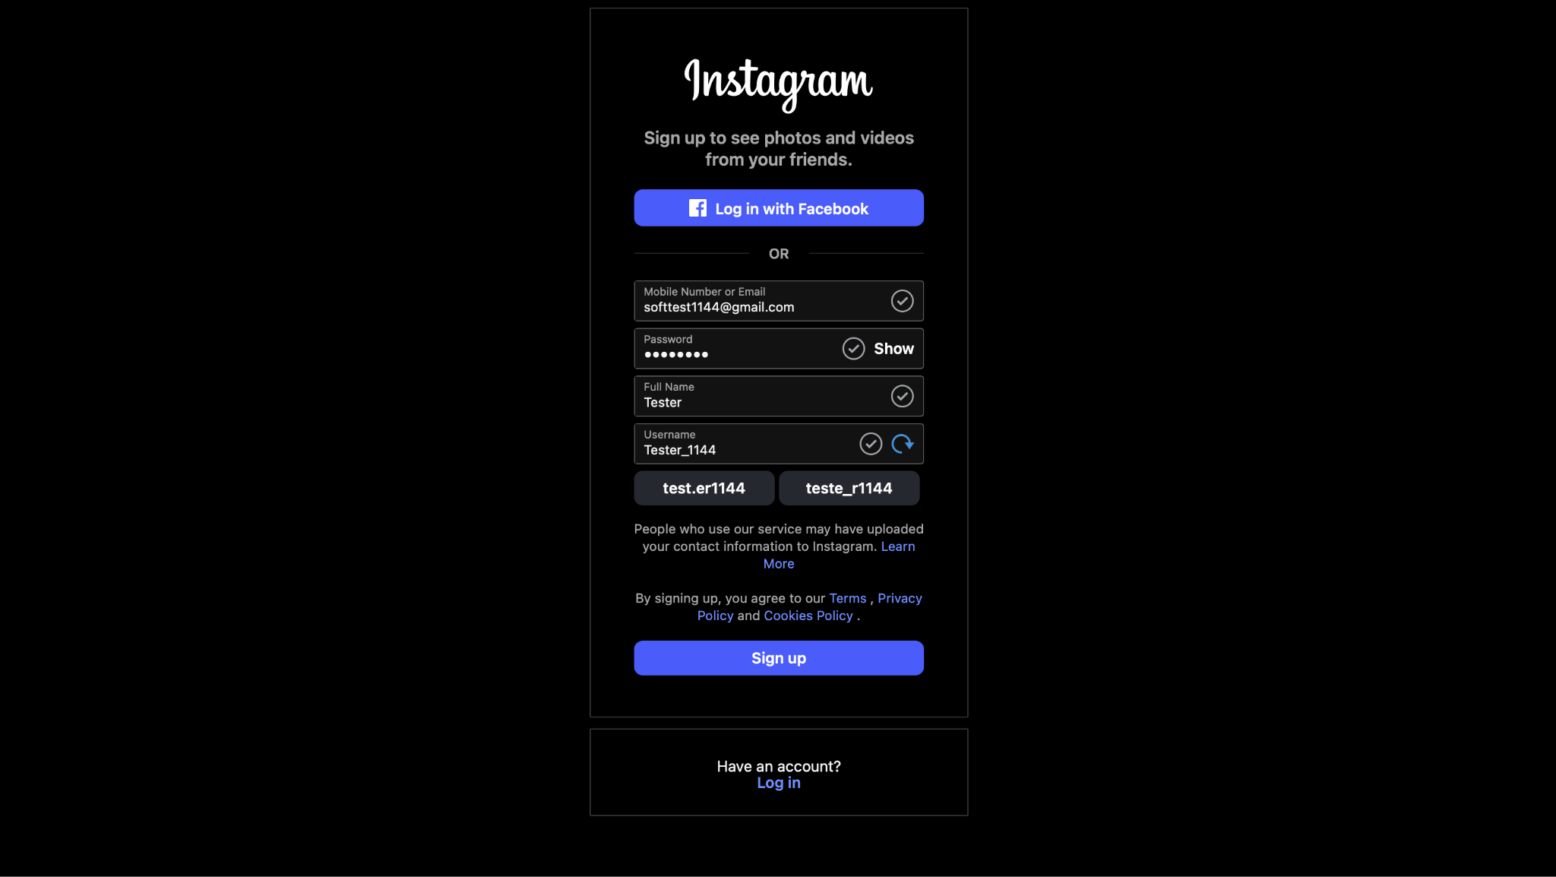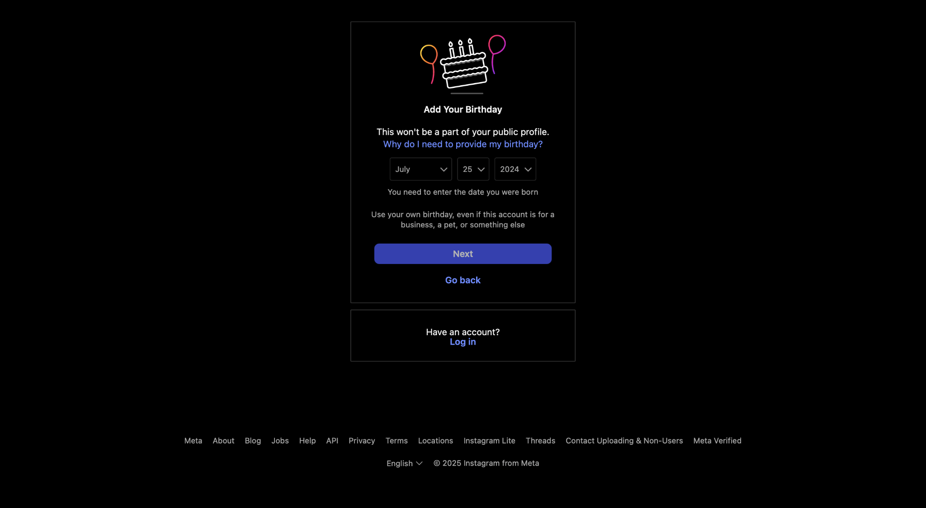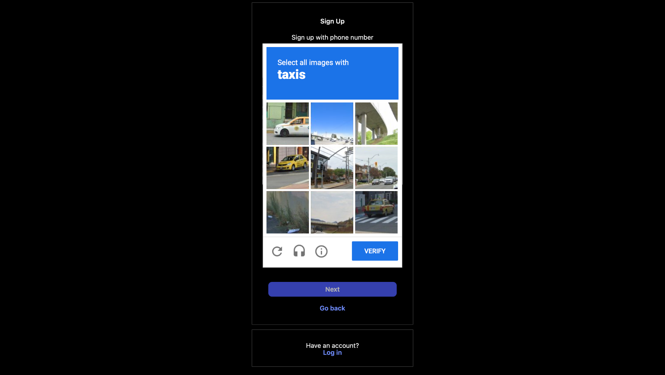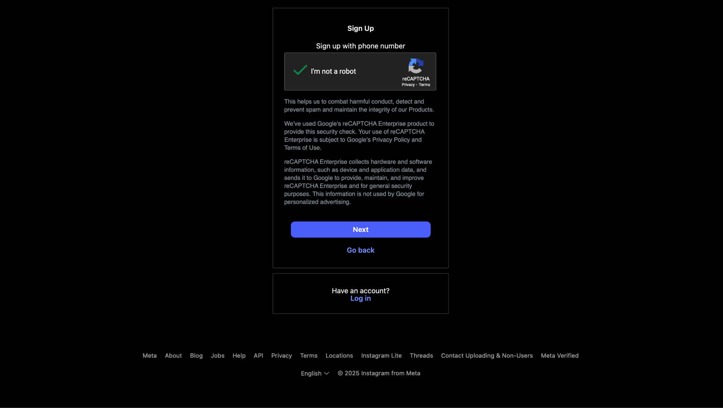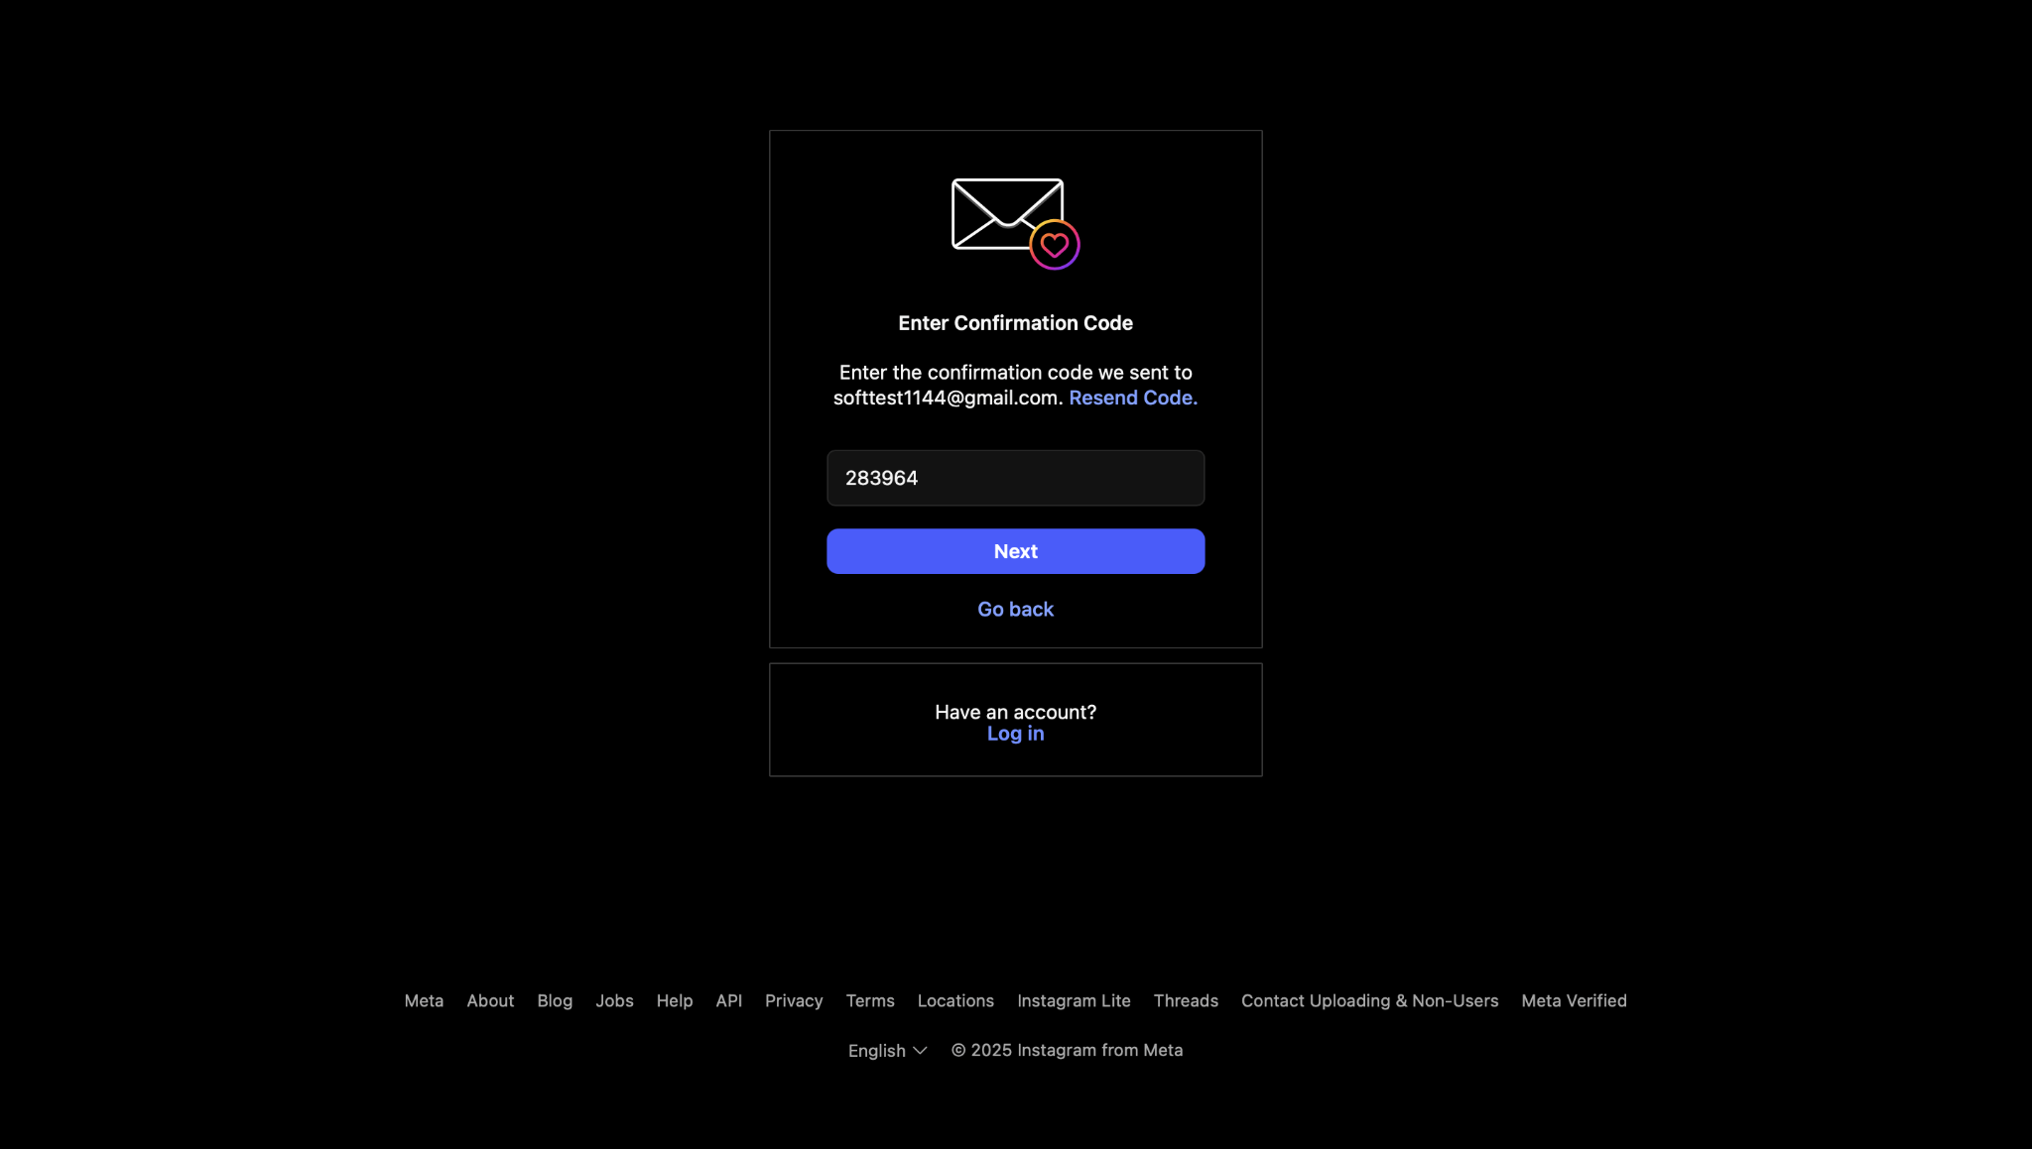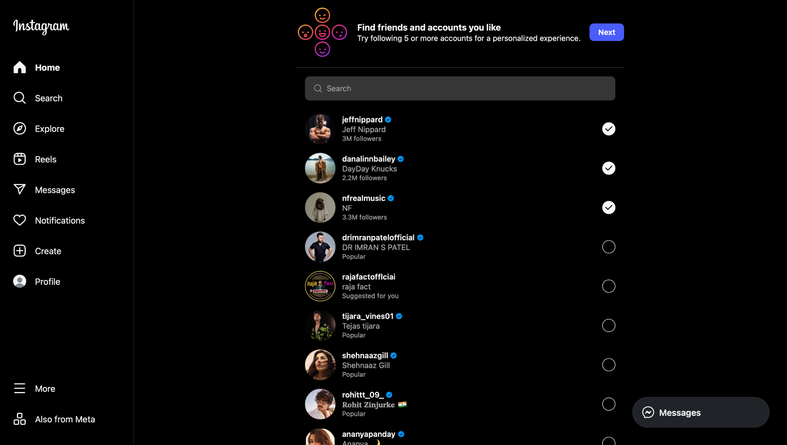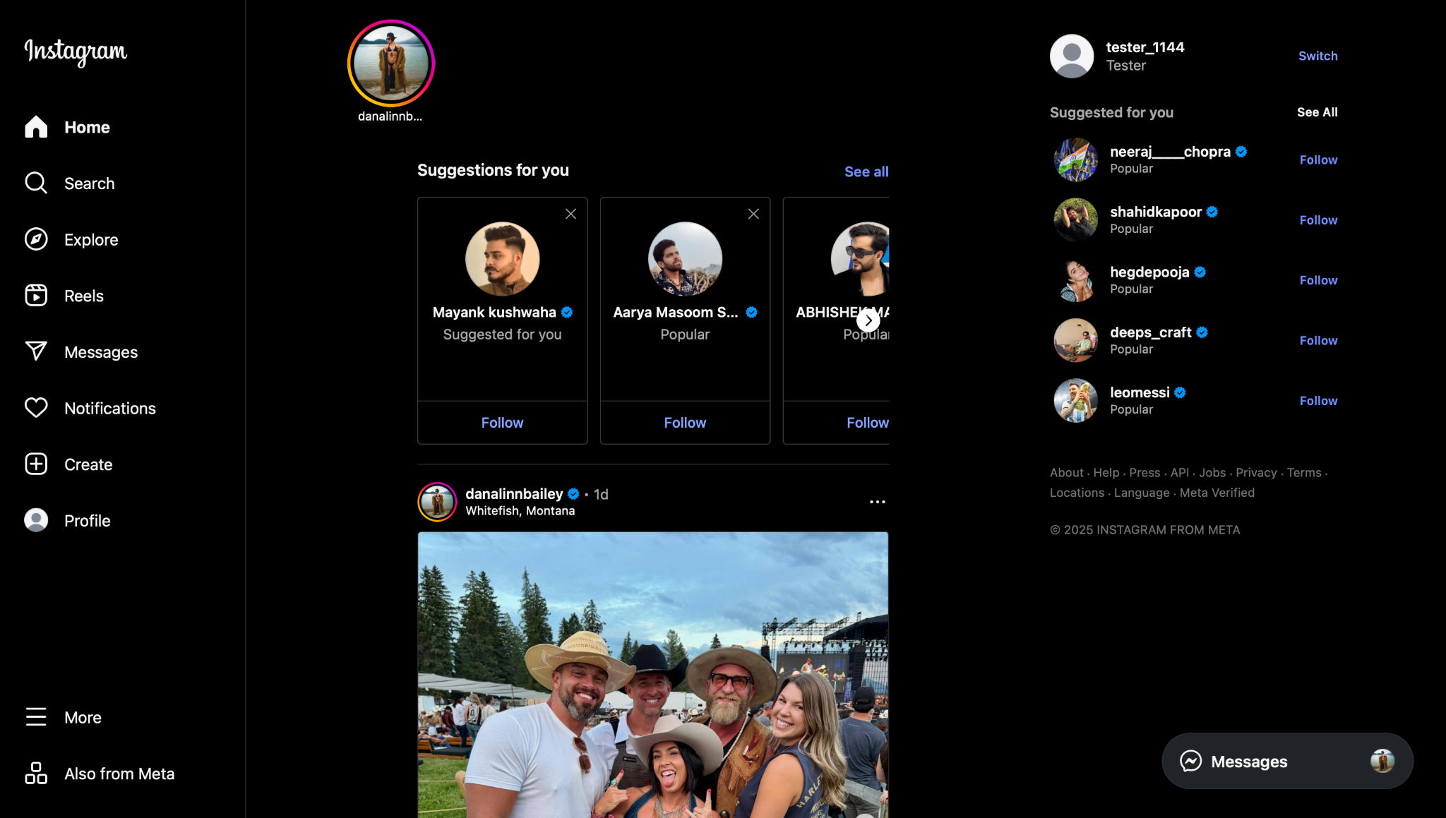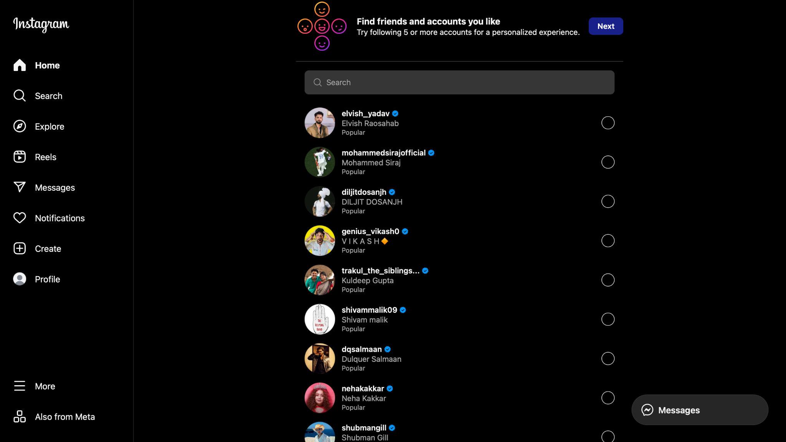**

### **Scenario ID: 1b**

**Scenario:** Sign up using already registered email  
**Test Steps:**

1. Click on Sign Up
2. Enter existing Email
3. Fill all fields
4. Click on Sign Up

**Screenshots:***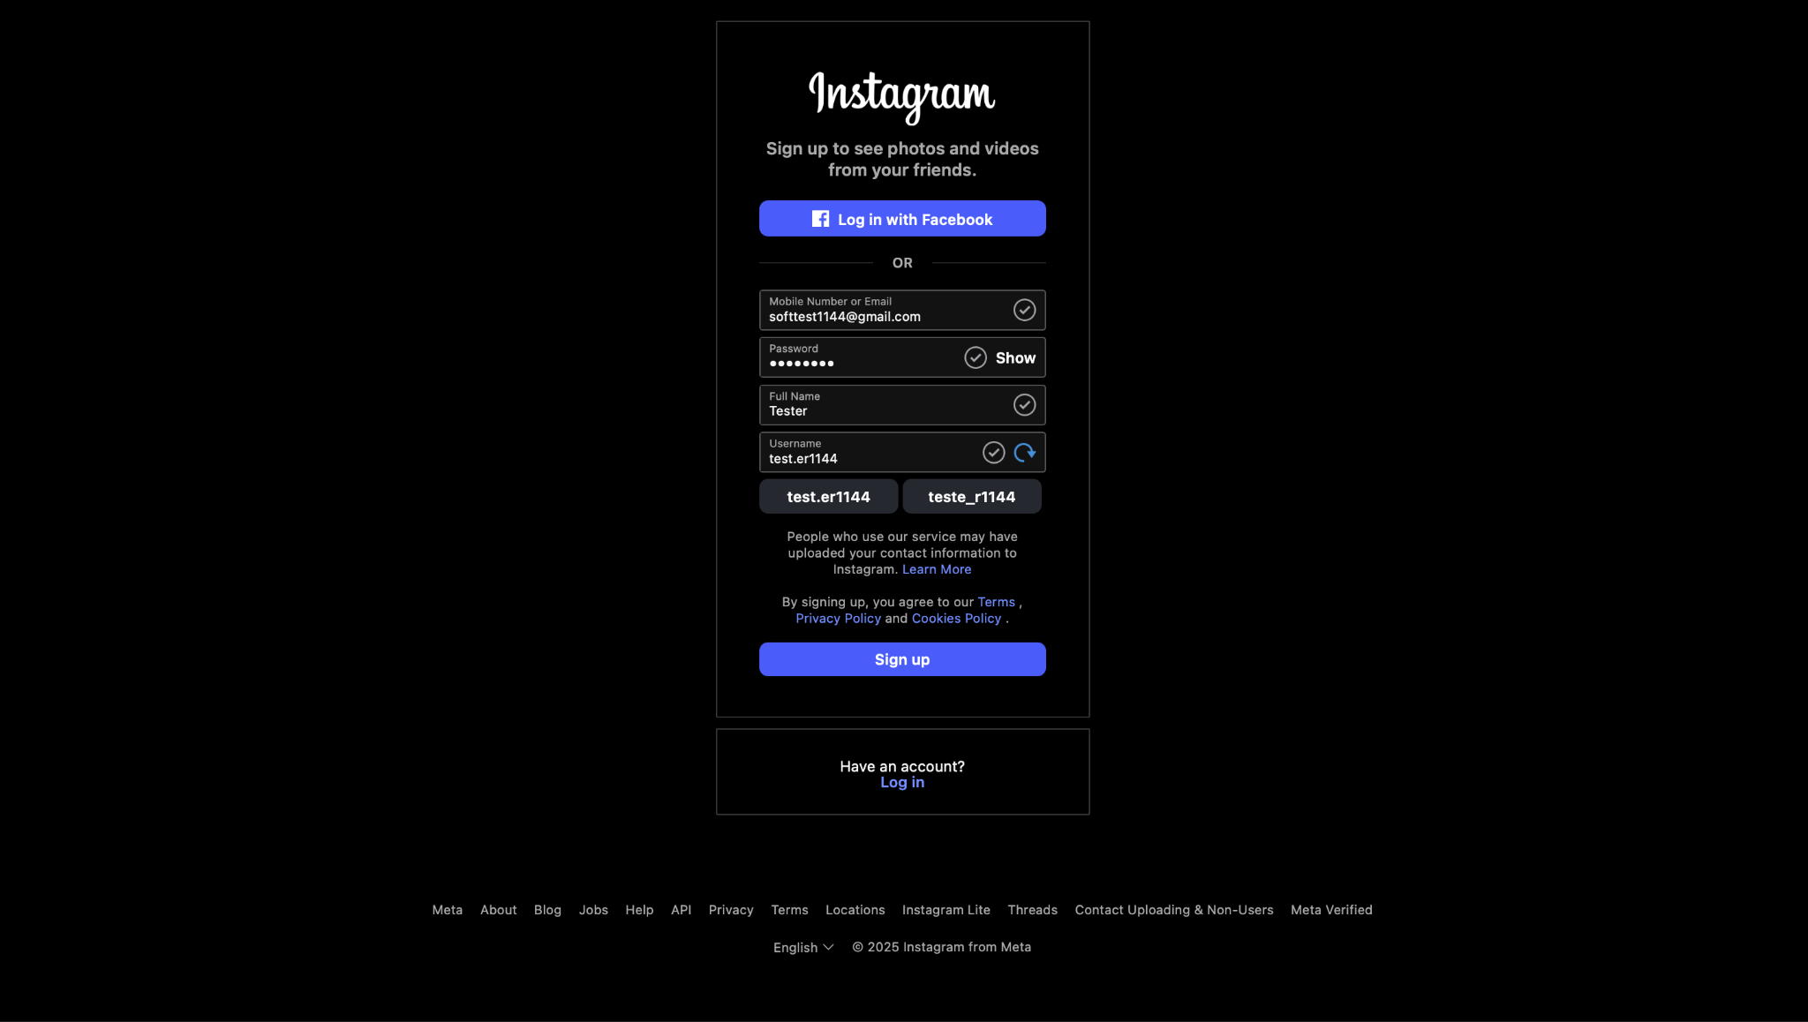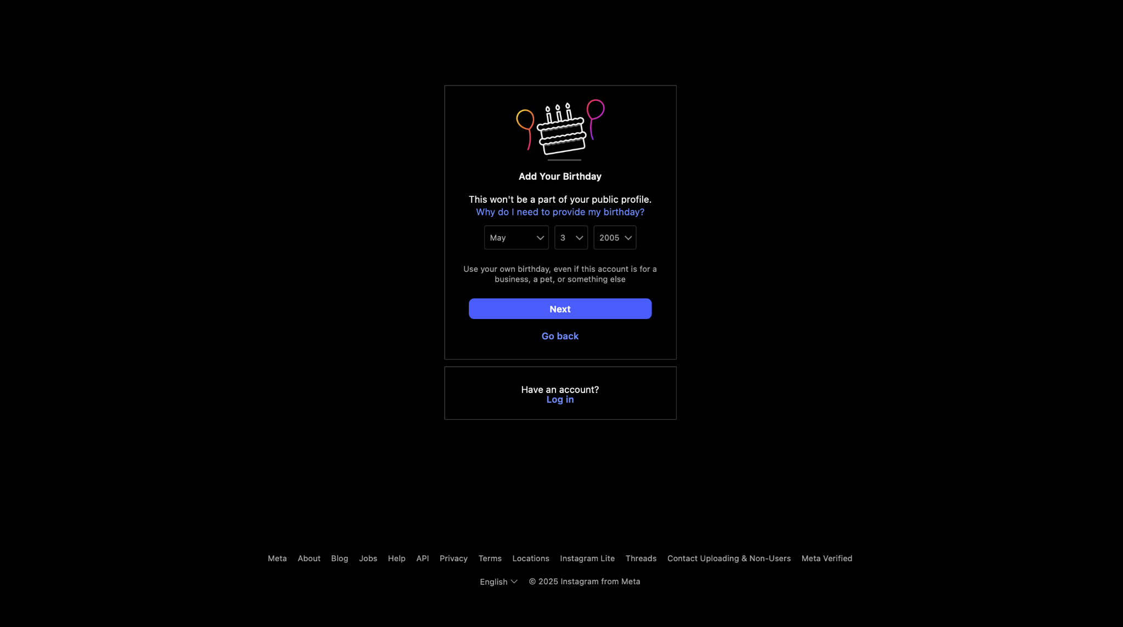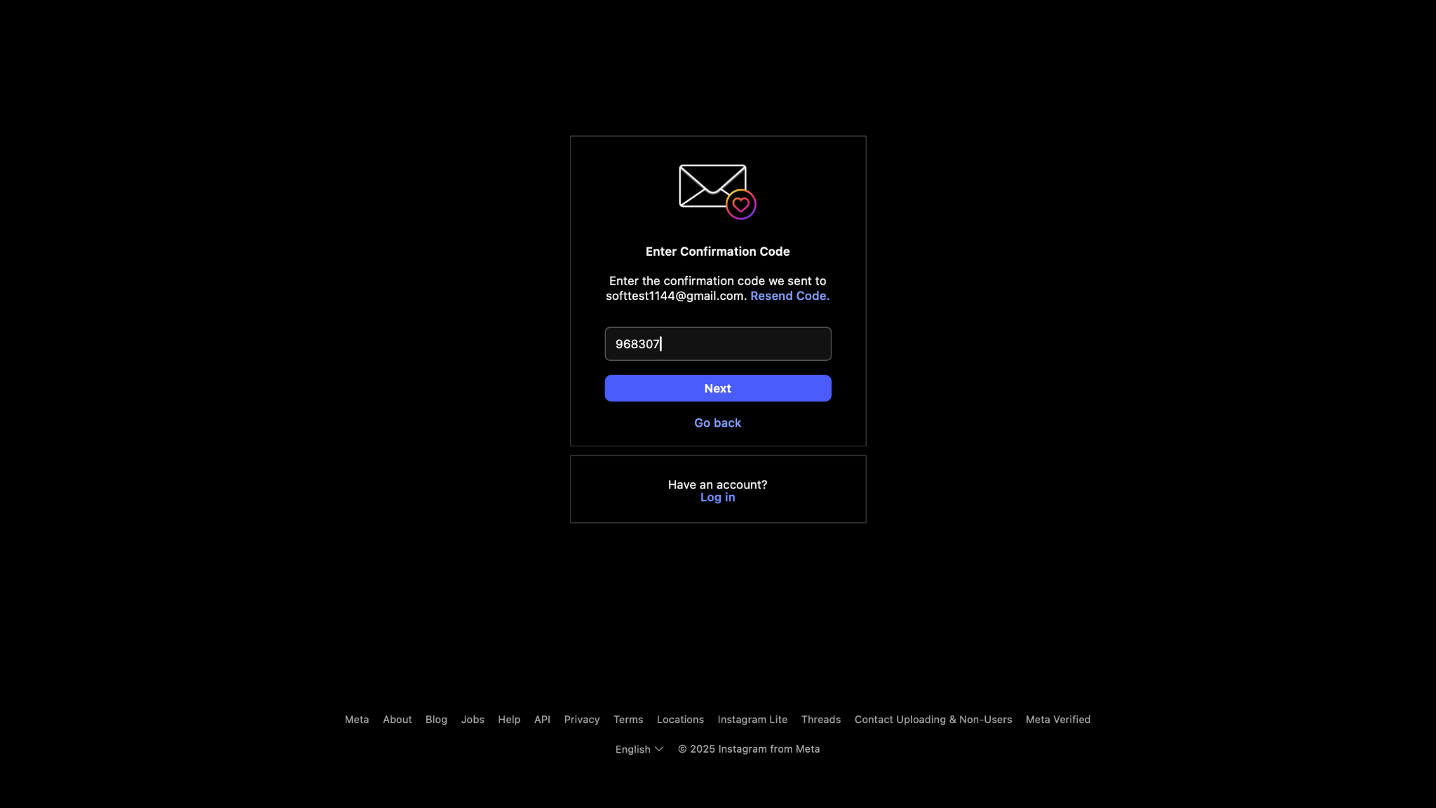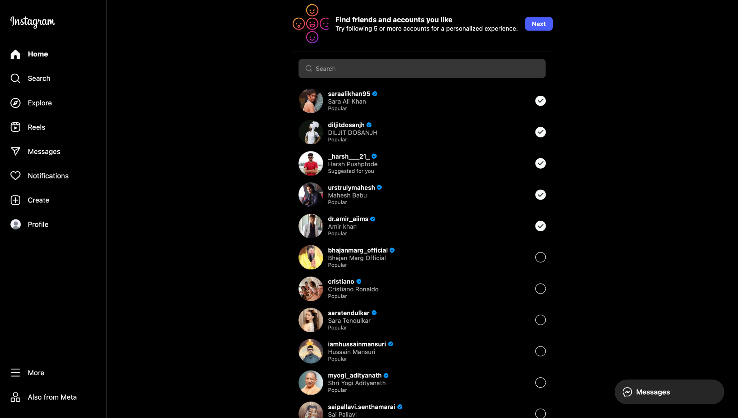*

### **Scenario ID: 1c**

**Scenario:** Sign up with invalid username  
**Test Steps:**

1. Click on Sign Up
2. Enter Username with special characters or spaces
3. Fill other fields
4. Click on Sign Up

**Screenshots:***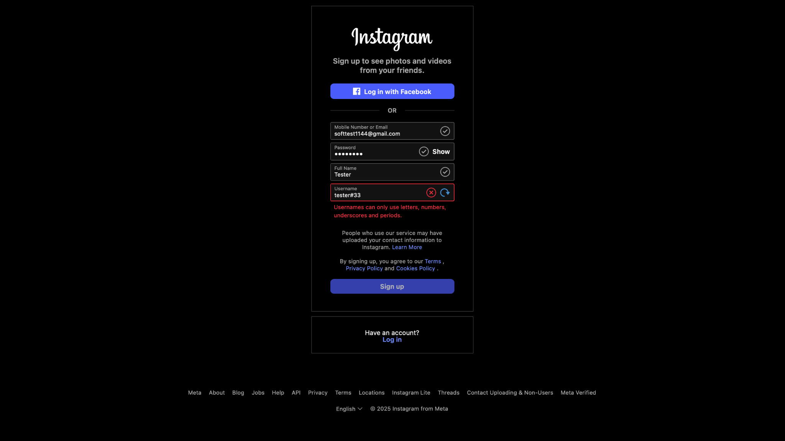*

### **Scenario ID: 1d**

**Scenario:** Sign up with only whitespace inputs  
**Test Steps:**

1. Click on Sign Up
2. Enter space characters in required fields
3. Click on Sign Up

**Screenshots:***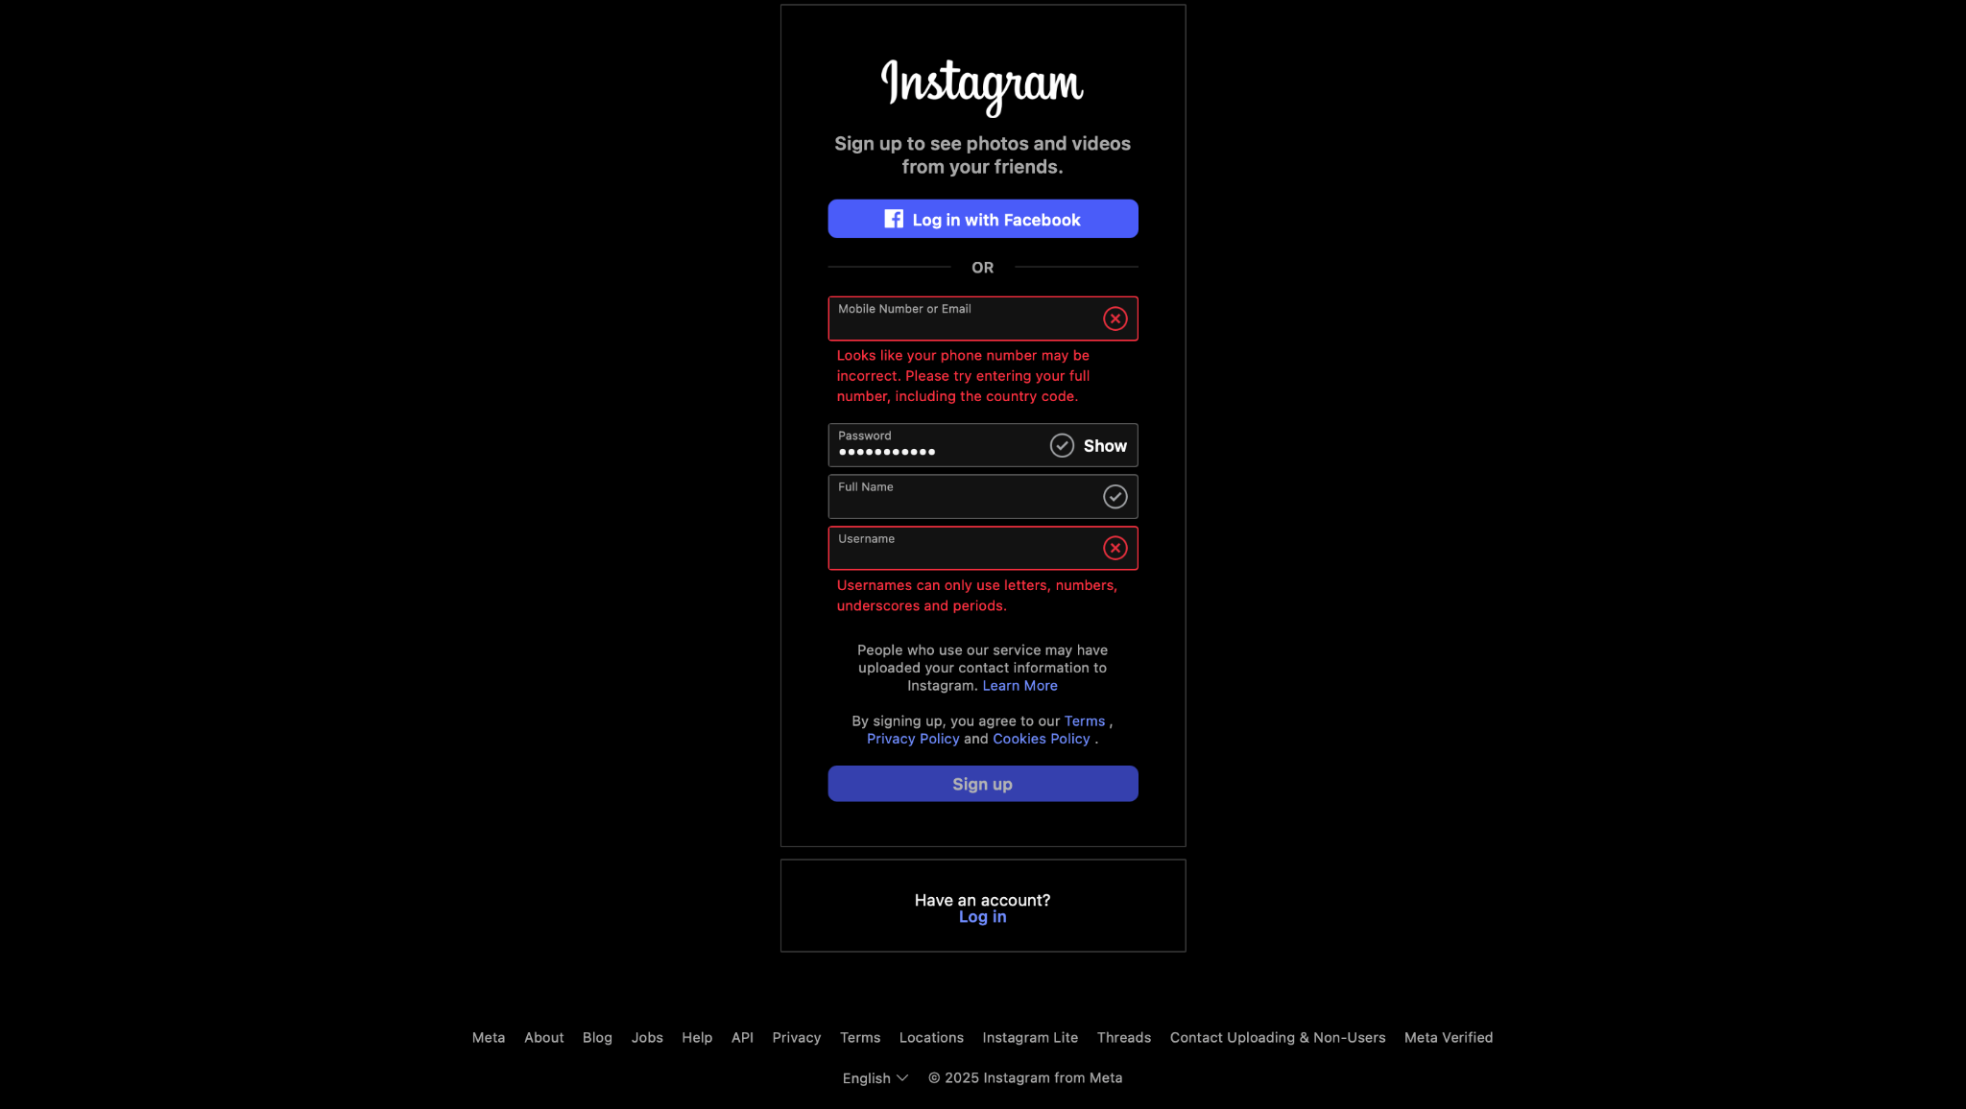*

### **Scenario ID: 1e**

**Scenario:** Sign up with weak password  
**Test Steps:**

1. Click on Sign Up
2. Enter valid Email, Name, and Username
3. Enter weak Password
4. Click on Sign Up

**Screenshots:***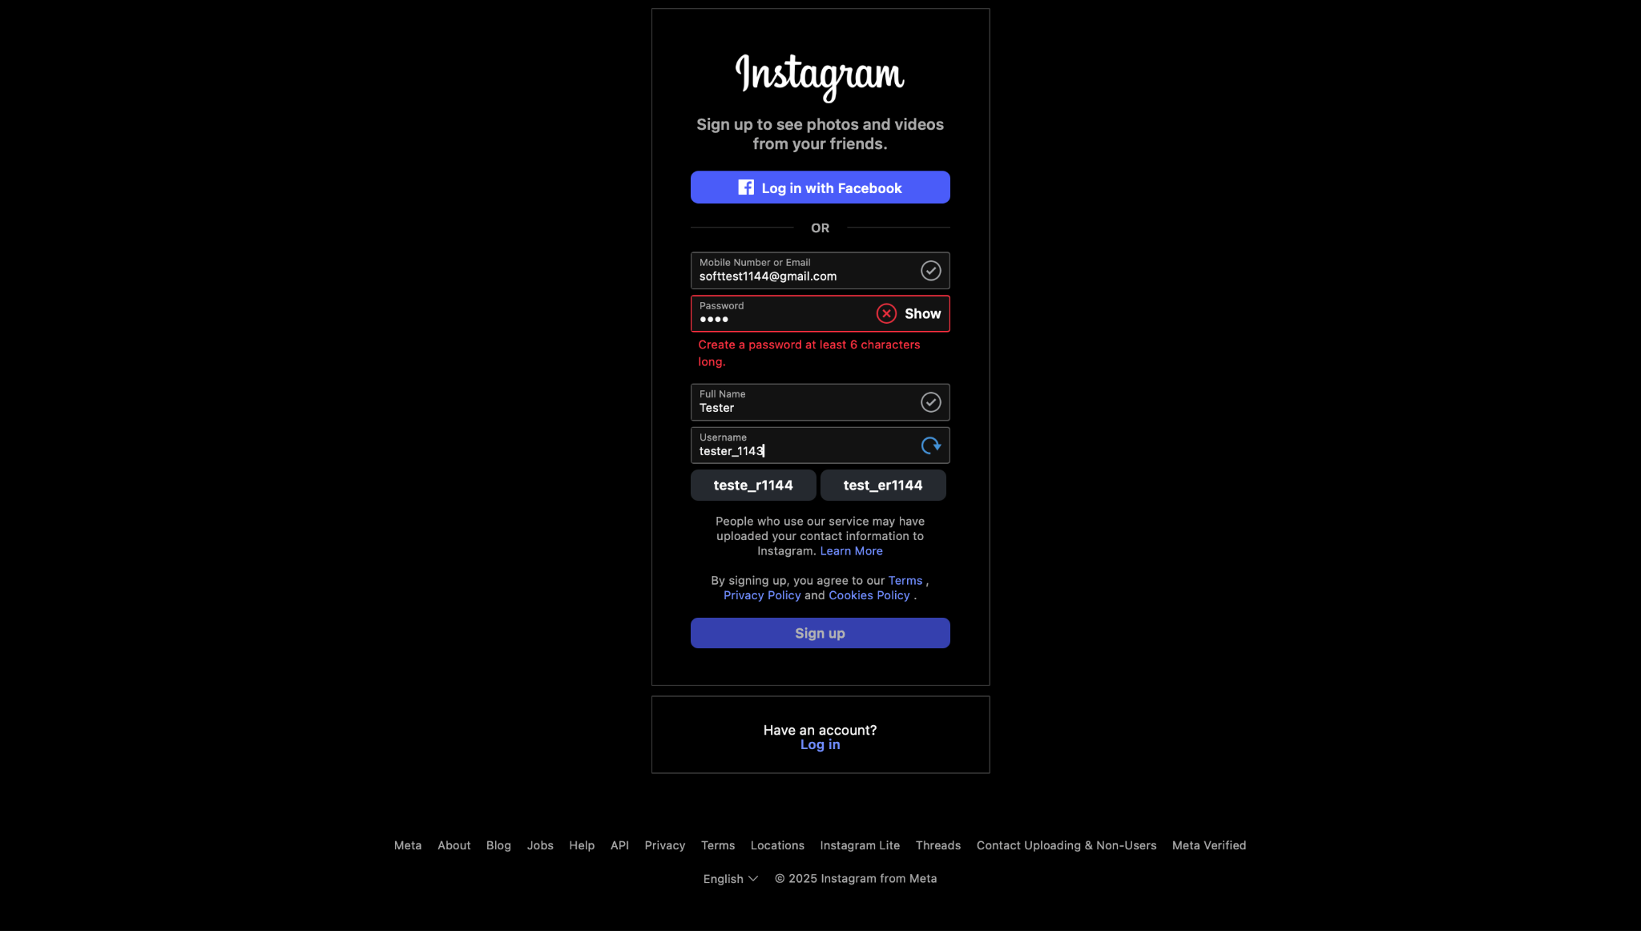*

### **Scenario ID: 1f**

**Scenario:** Check password visibility toggle  
**Test Steps:**

1. Click on Sign Up
2. Enter Password
3. Click on eye icon beside password field

**Screenshots:***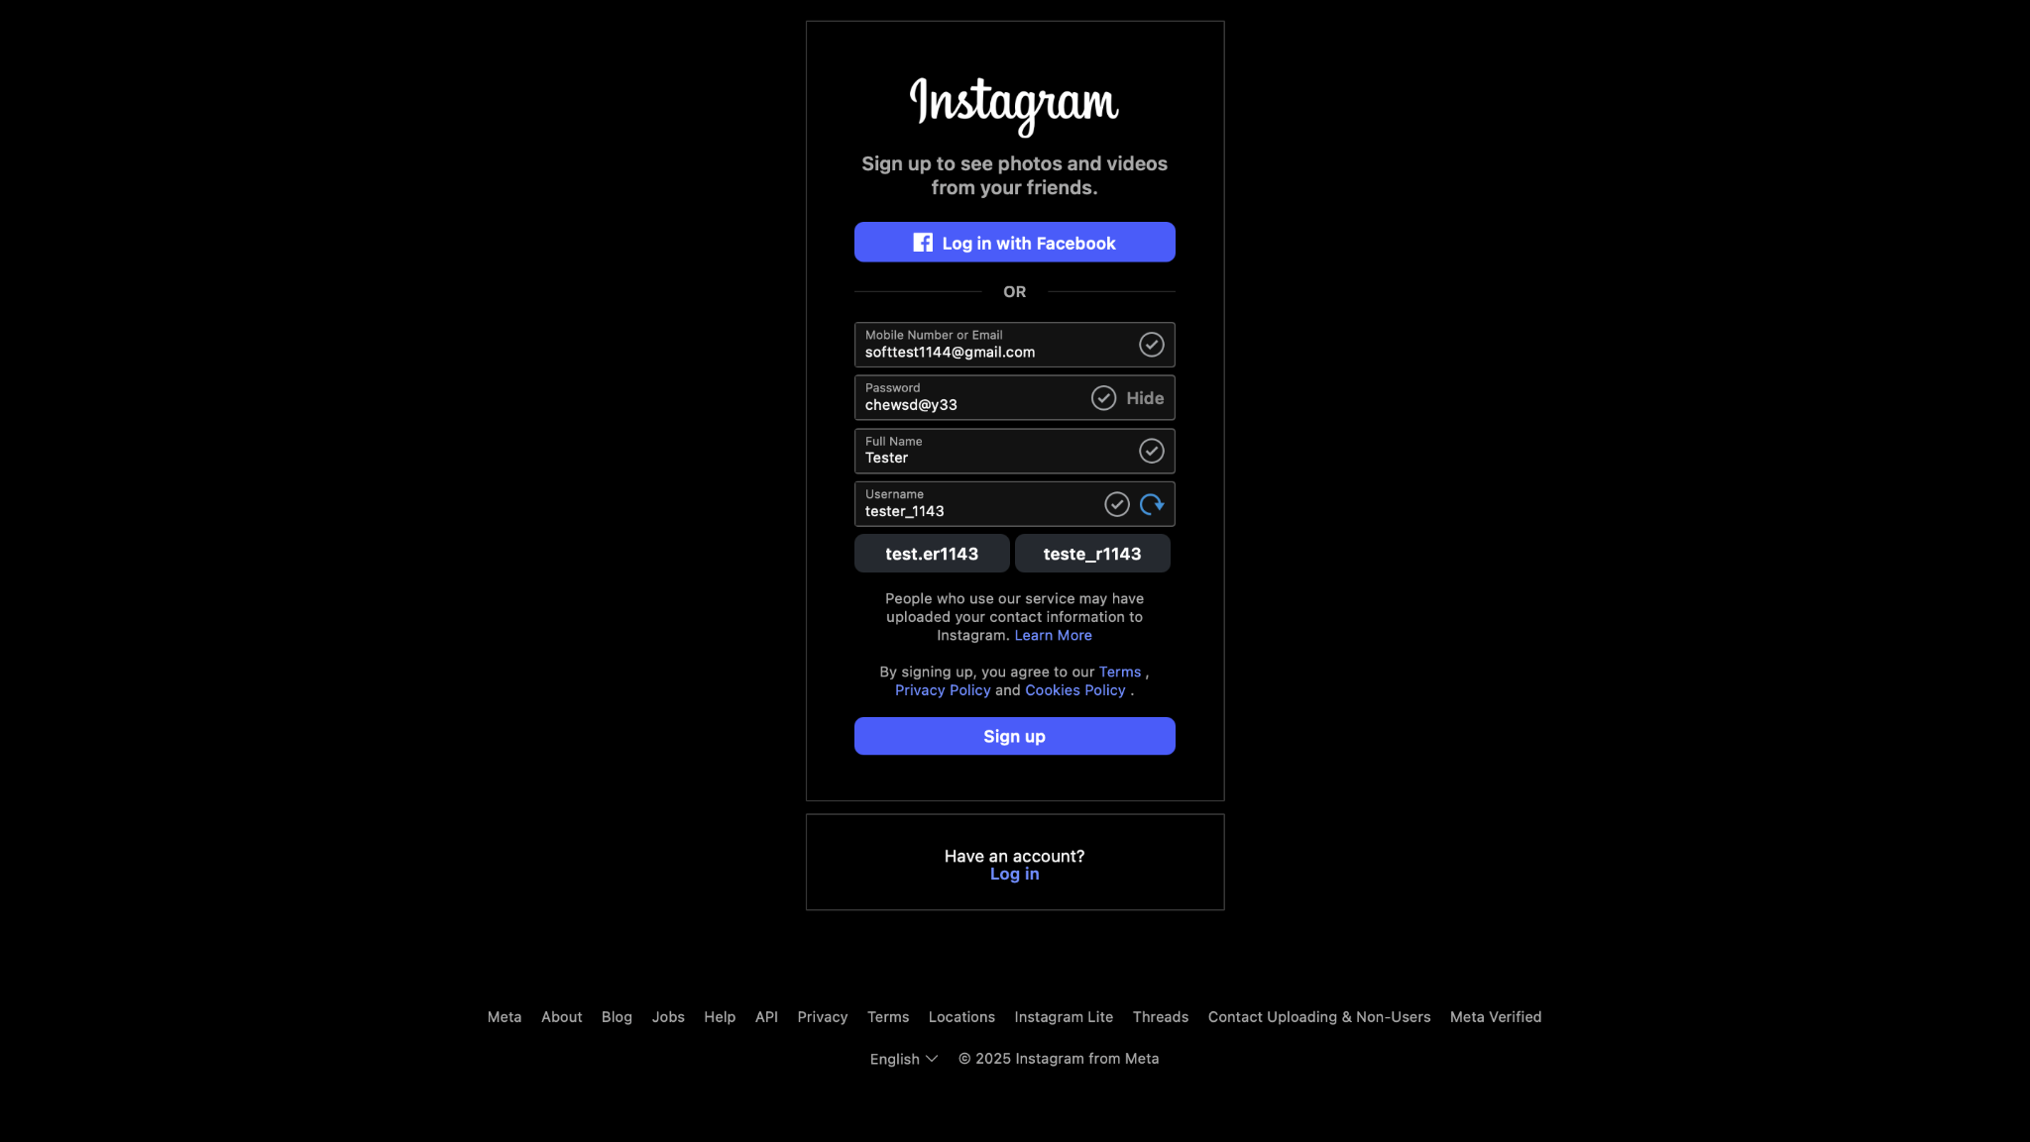*

### **Scenario ID: 1g**

**Scenario:** Check responsive layout of sign up form  
**Test Steps:**

1. Open Sign Up page
2. Resize browser window or open on mobile

**Screenshots:  
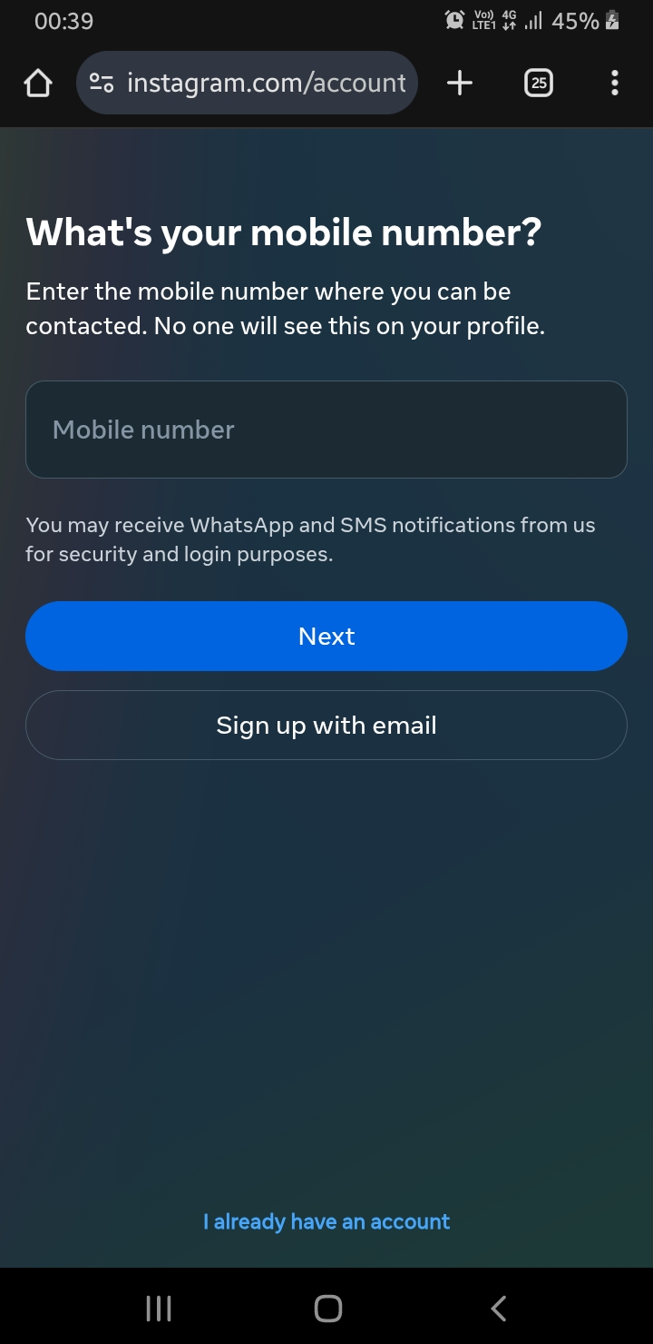**

### **Scenario ID: 1h**

**Scenario:** Sign up with international phone number  
**Test Steps:**

1. Click on Sign Up
2. Enter phone number with country code
3. Fill other fields
4. Click on Sign Up

**Screenshots:***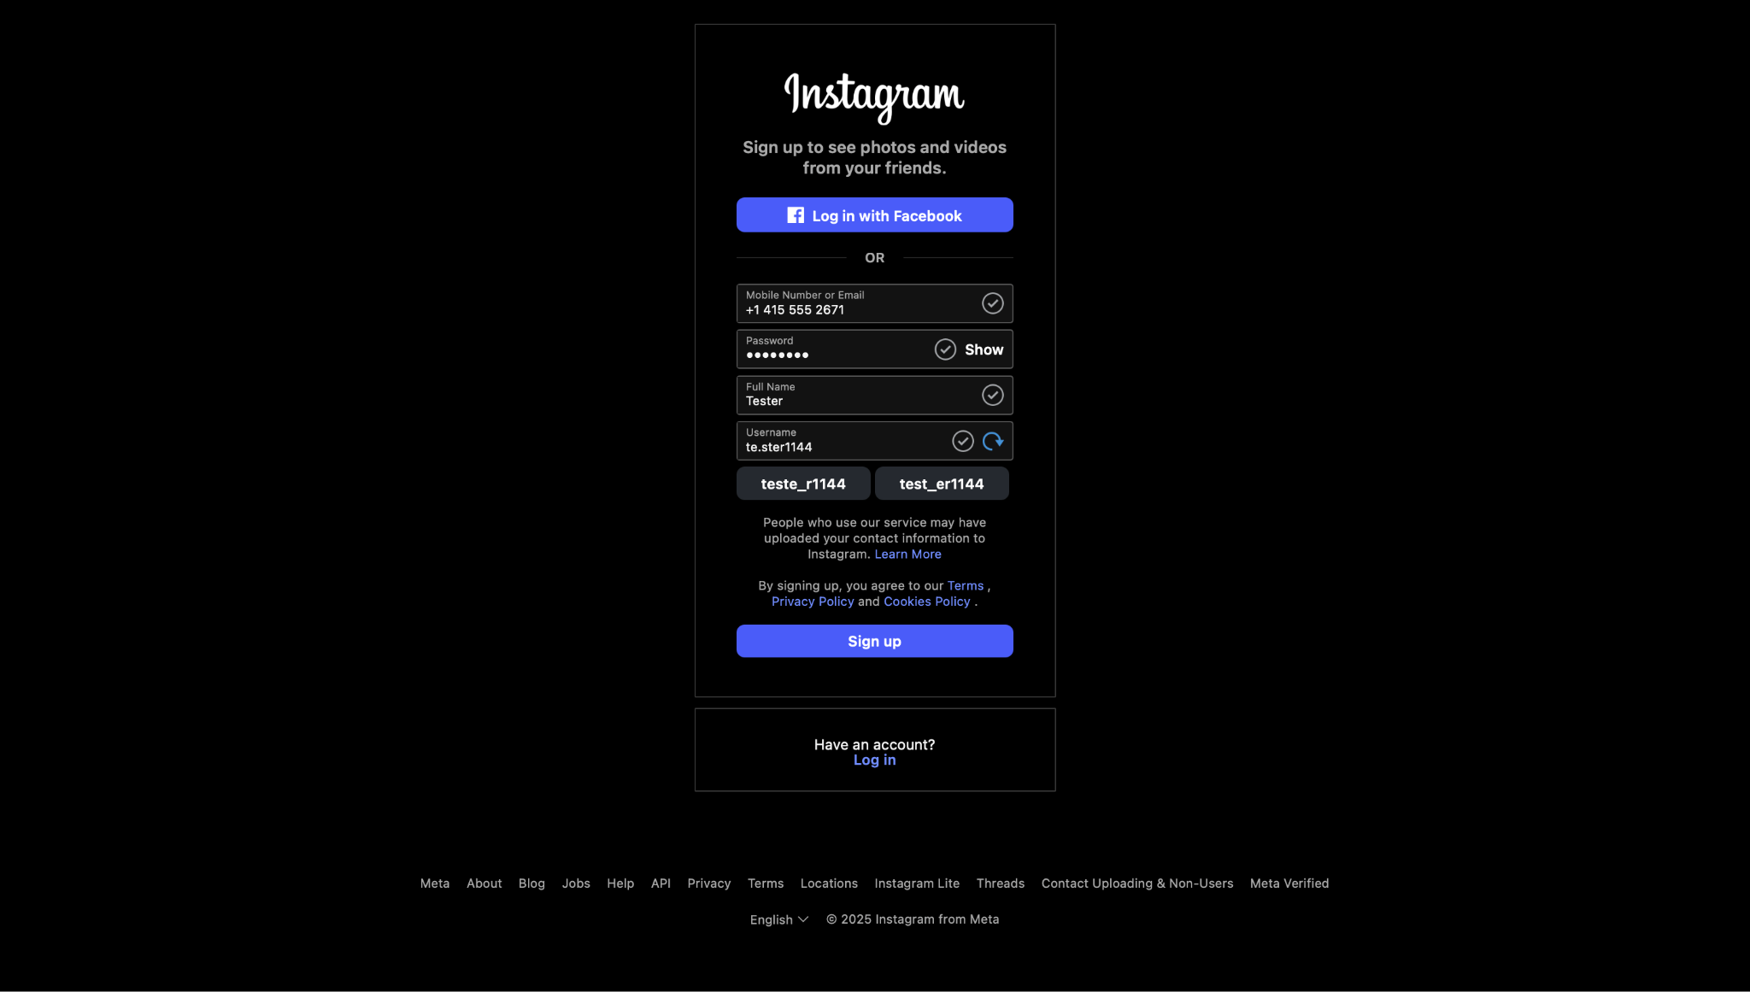*

### **Scenario ID: 2a**

**Scenario:** Login with valid credentials  
**Test Steps:**

1. Click on Log In
2. Enter valid Username and Password
3. Click Log In

**Screenshots:**

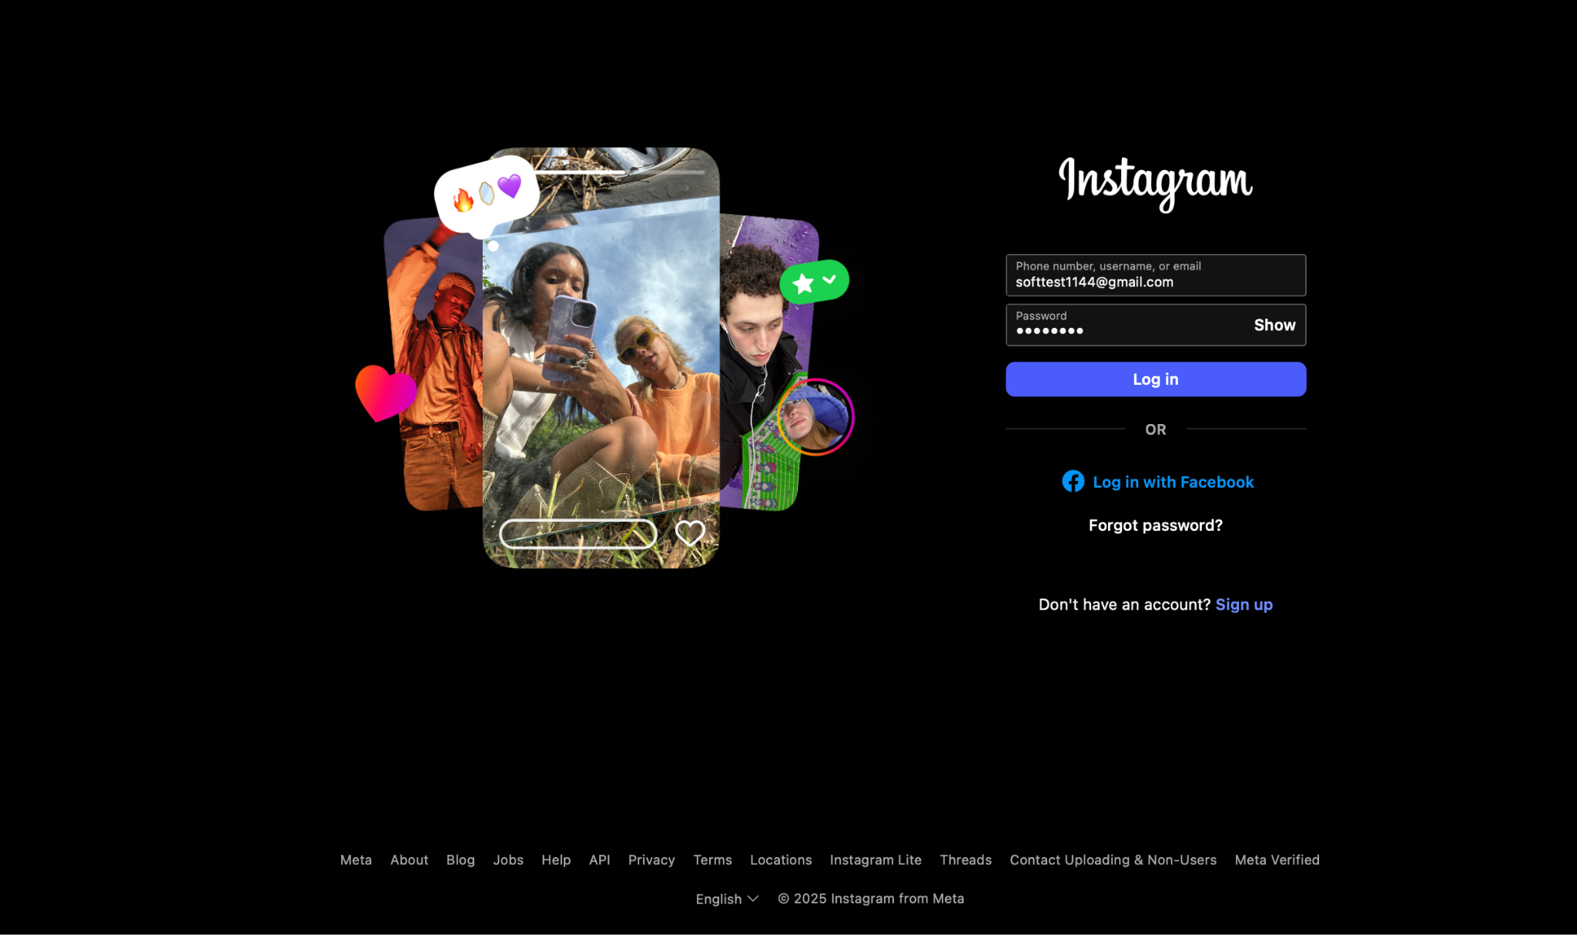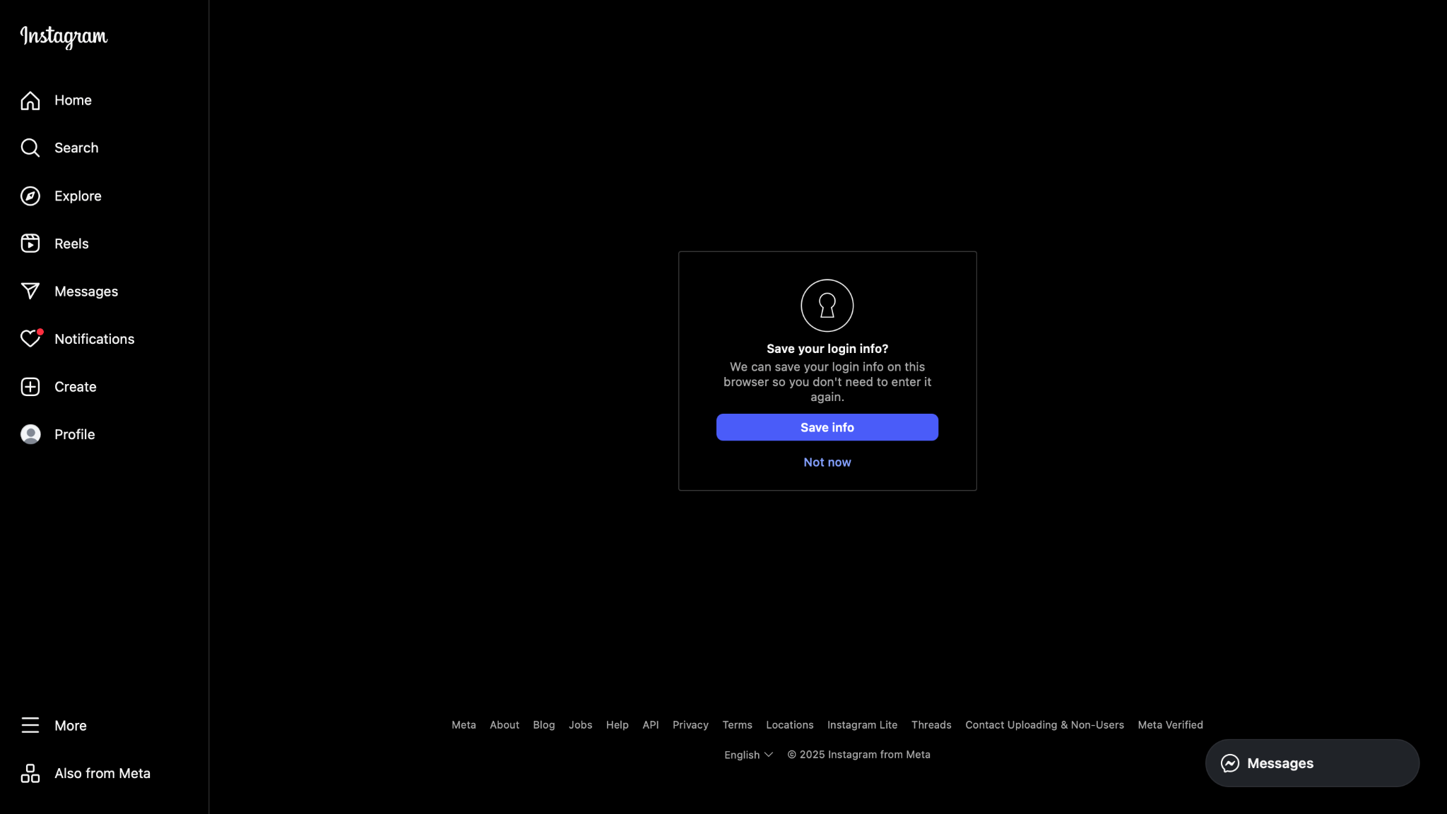

### **Scenario ID: 2b**

**Scenario:** Login with wrong password  
**Test Steps:**

1. Click on Log In
2. Enter valid username and wrong password
3. Click Log In

**Screenshots:***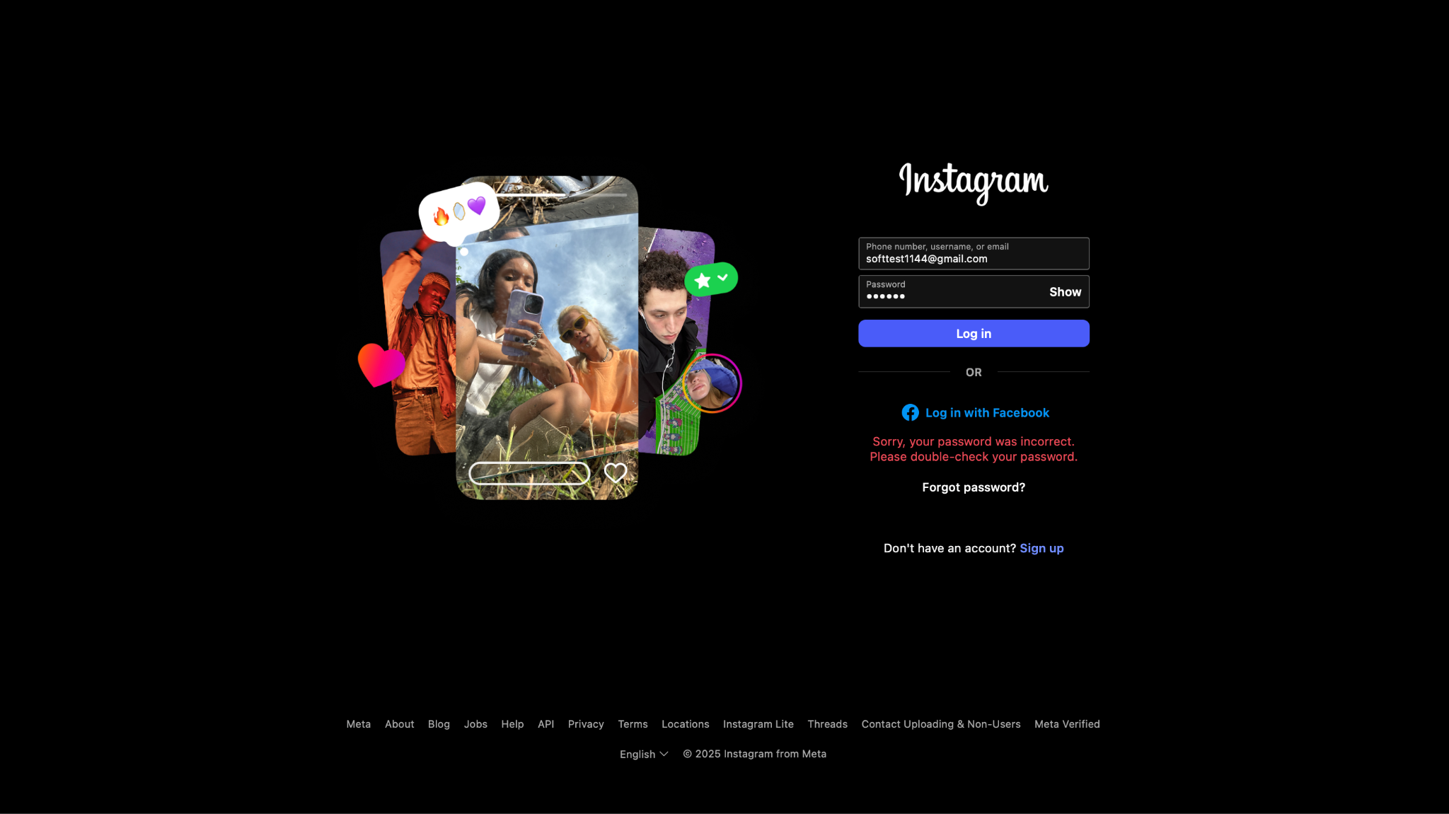*

### **Scenario ID: 2c**

**Scenario:** Try login with empty fields  
**Test Steps:**

1. Click on Log In
2. Leave username and/or password blank
3. Click Log In

**Screenshots:  
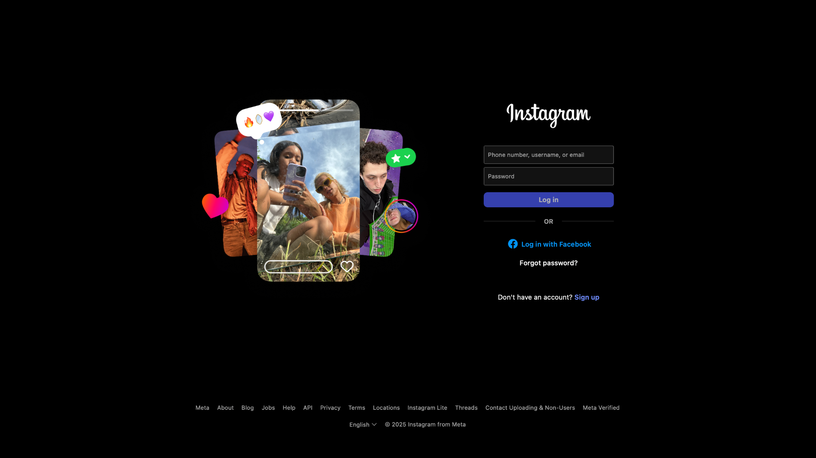**

### **Scenario ID: 2d**

**Scenario:** Login with case changes in email, username, or password  
**Test Steps:**

1. Click on Log In
2. Enter email/username/password with altered letter casing
3. Click Log In

**Screenshots:***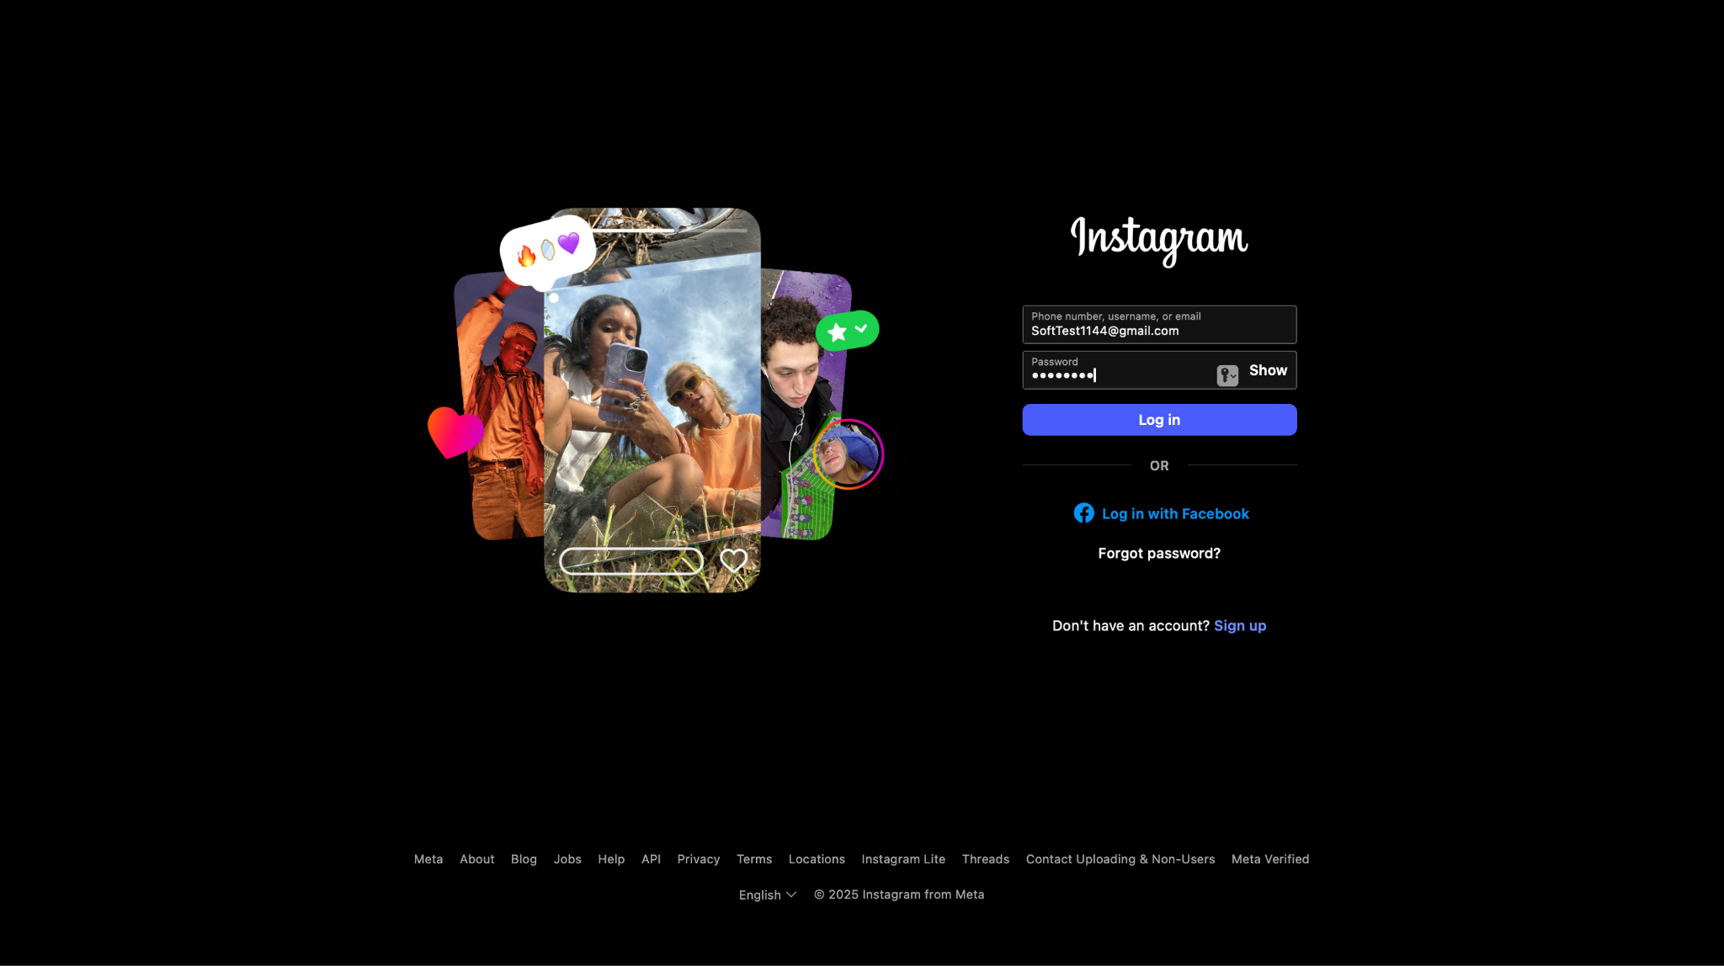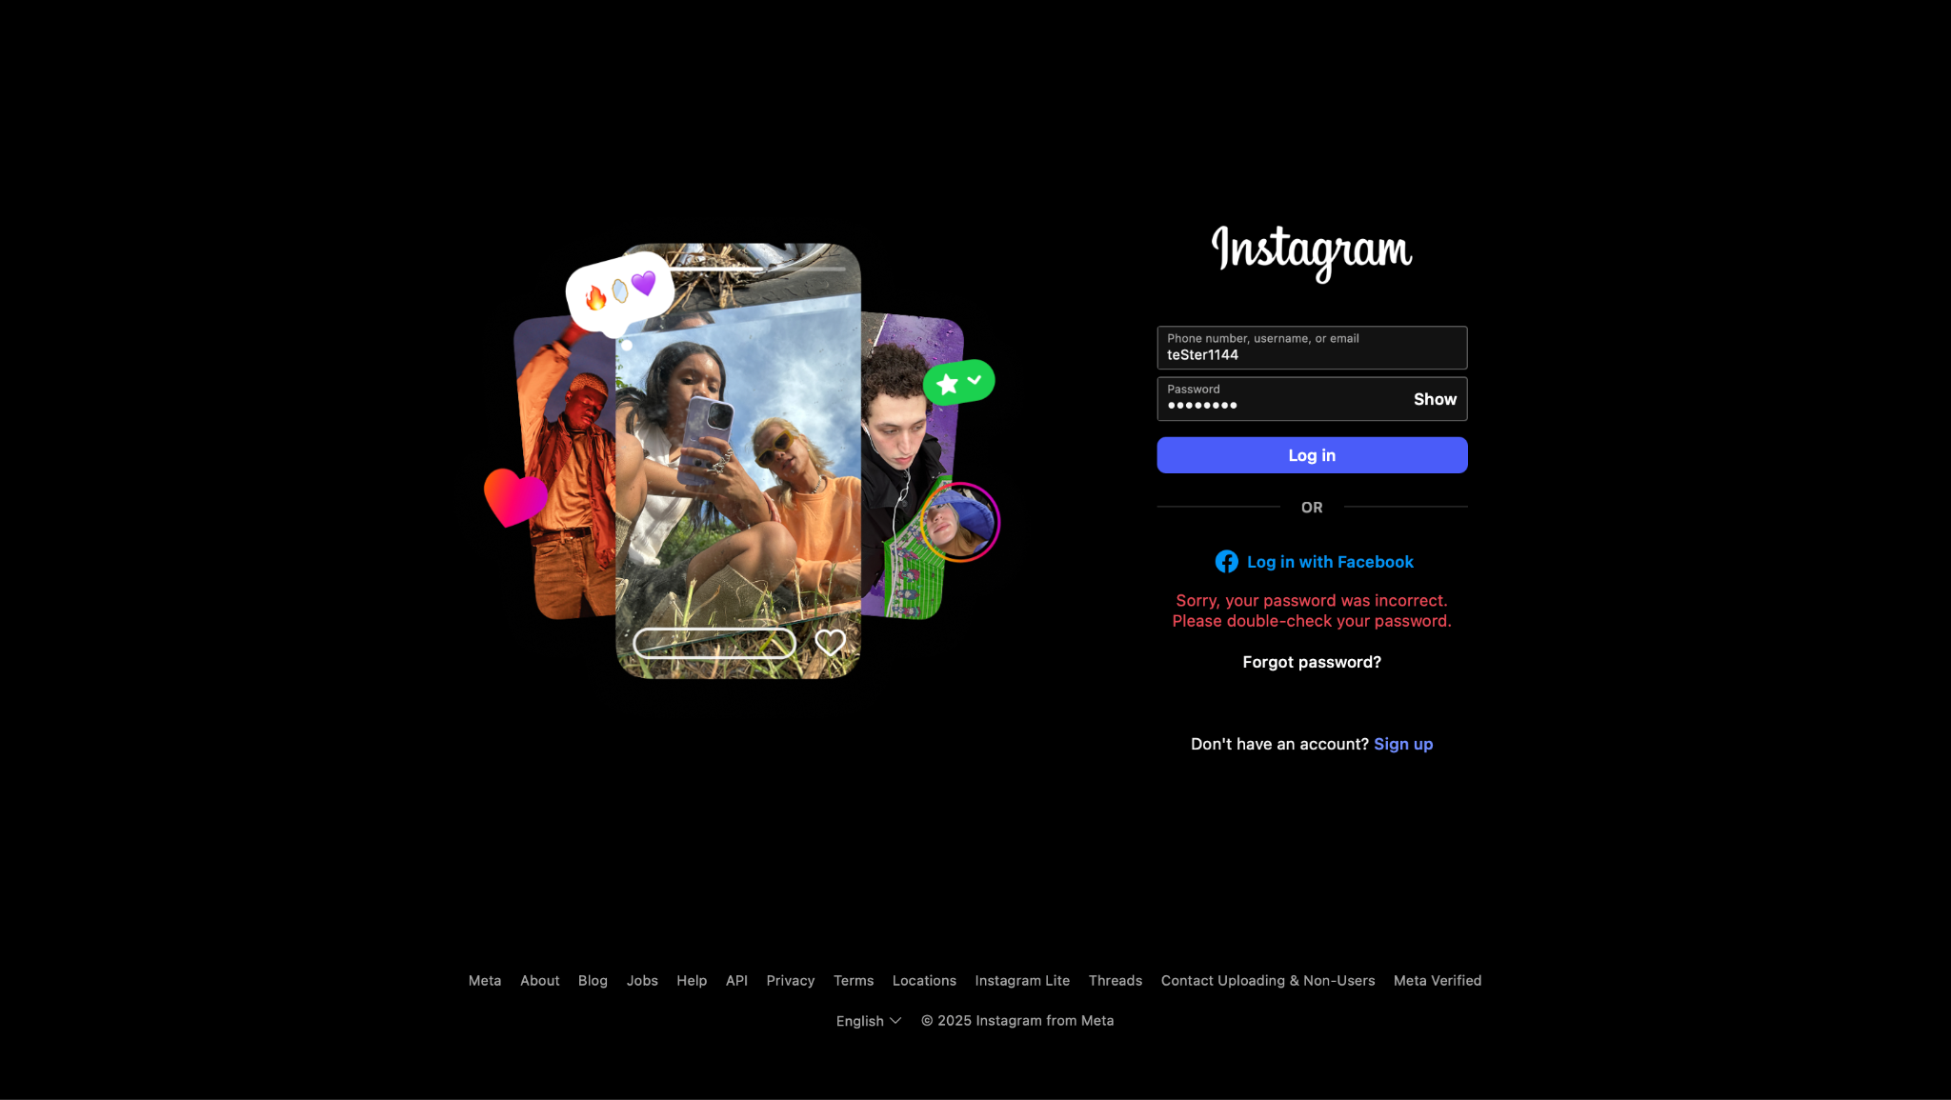*

### **Scenario ID: 2e**

**Scenario:** Forgot password flow  
**Test Steps:**

1. Click on Log In
2. Click on “Forgot Password?”
3. Enter email/username
4. Follow reset steps

**Screenshots:***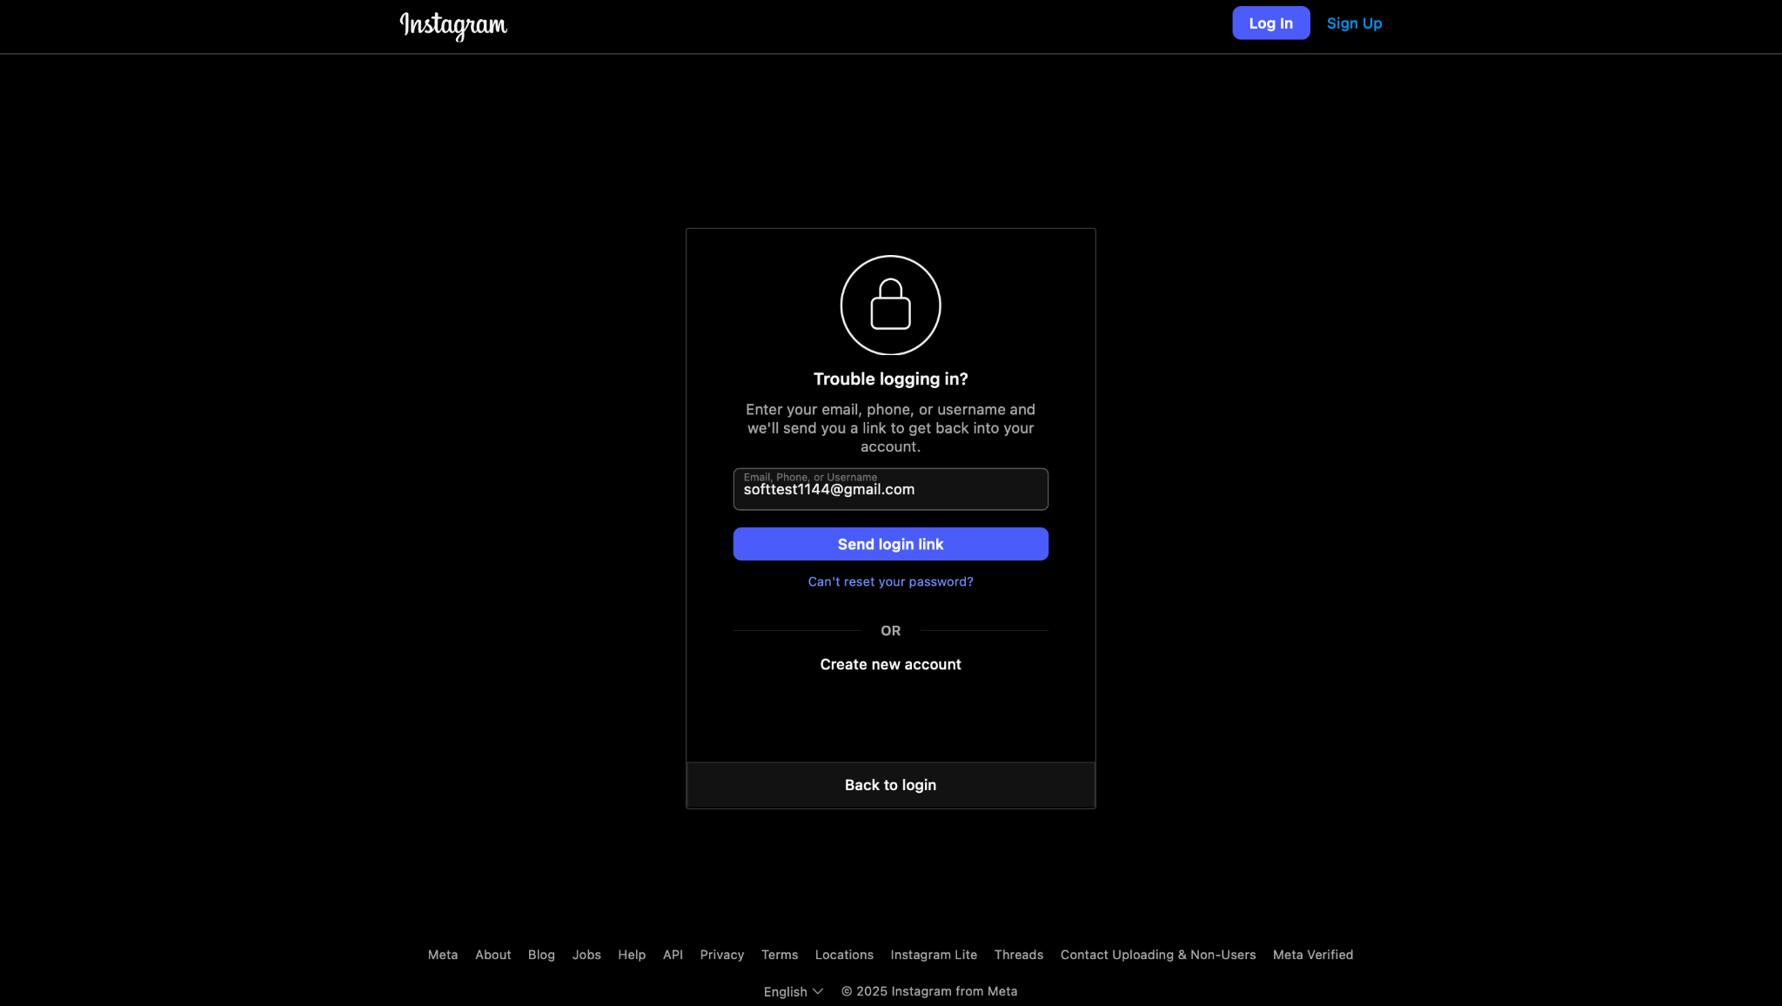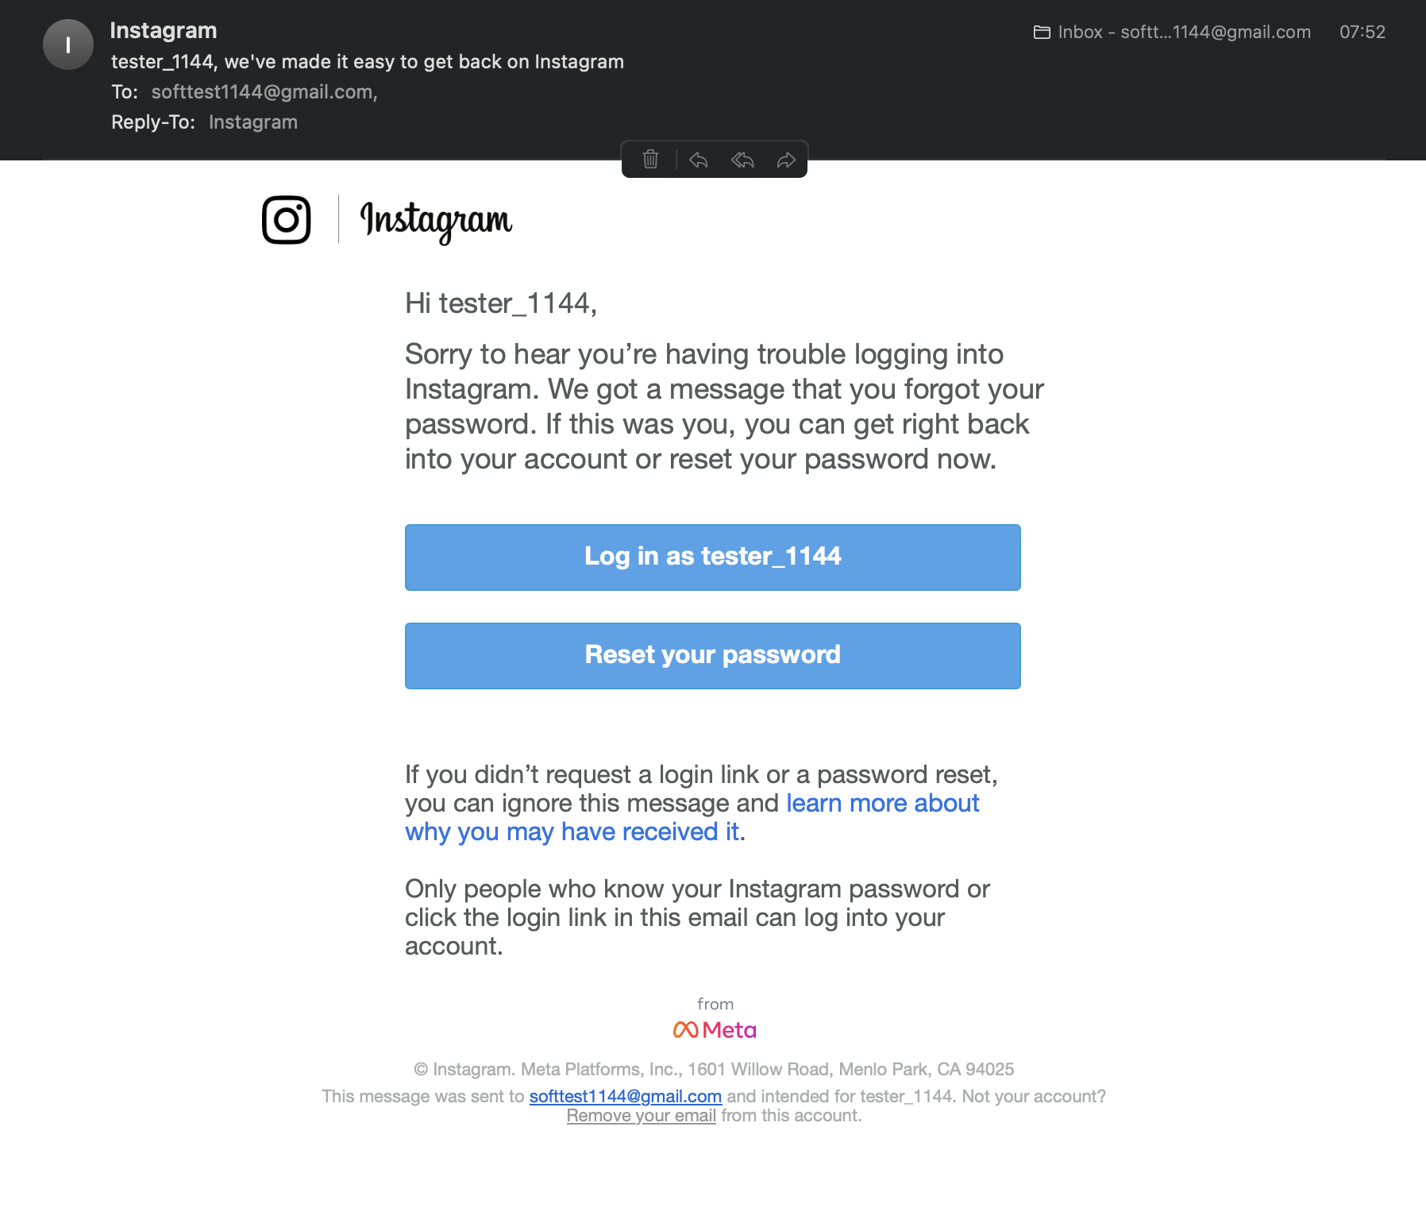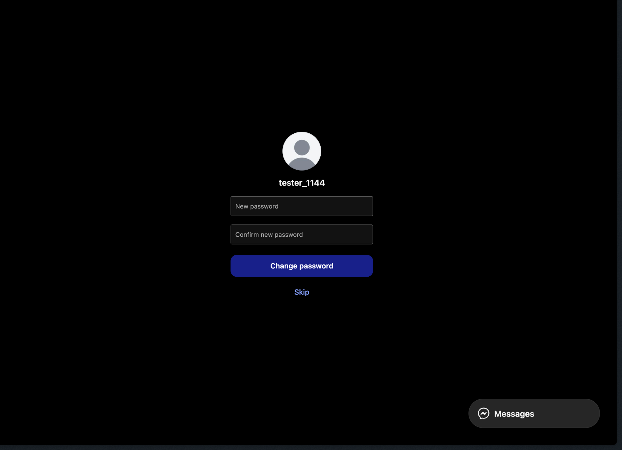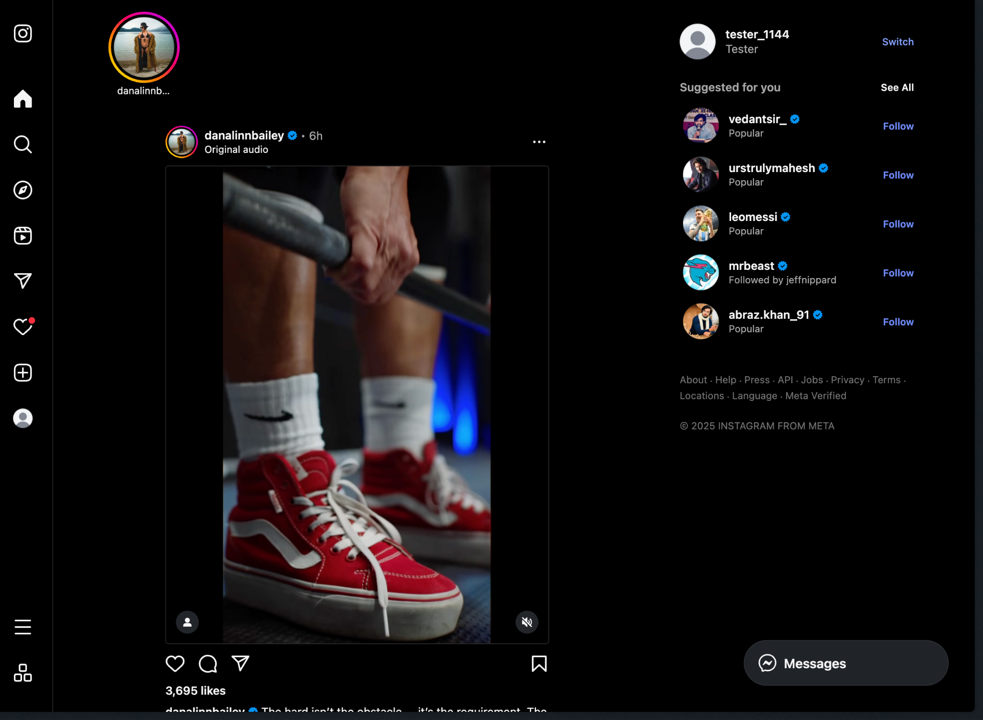*

### **Scenario ID: 2f**

**Scenario:** Check login field visibility on mobile  
**Test Steps:**

1. Open login page on mobile device

**Screenshots:**

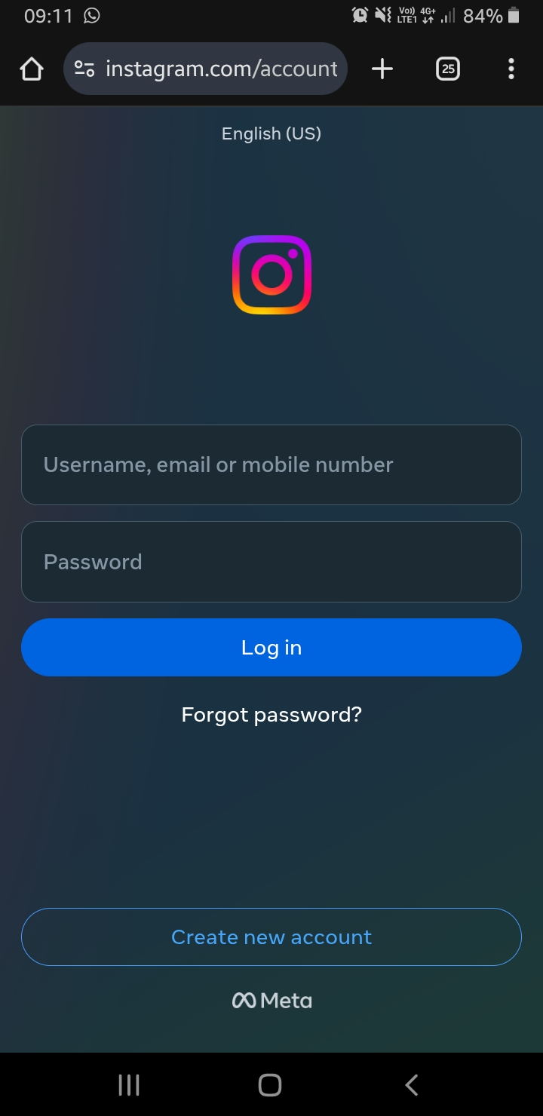

### **Scenario ID: 2g**

**Scenario:** Login using “Log in with Facebook”  
**Test Steps:**

1. Click on 'Log in with Facebook' or 'Log in with Google'
2. Select or enter account details if prompted
3. Grant permissions if needed

**Screenshots:***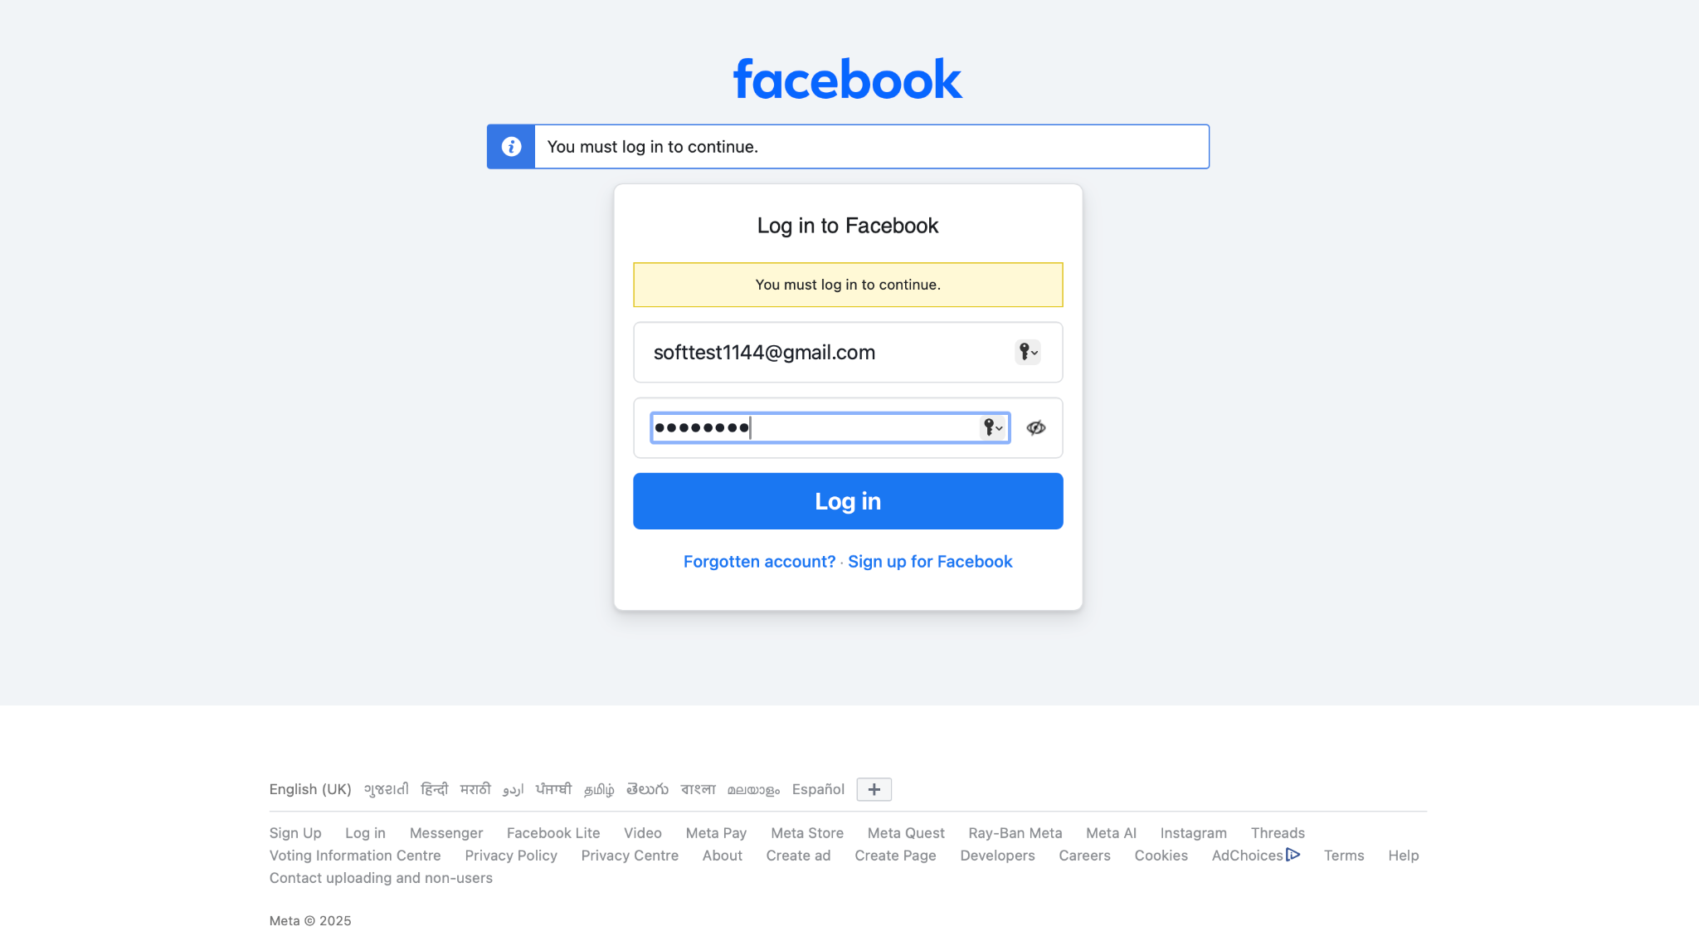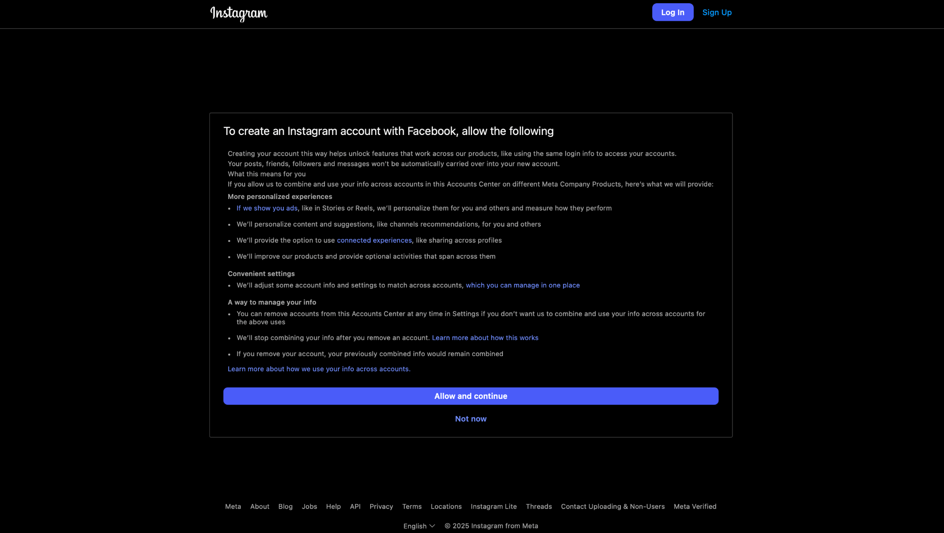*

### **Scenario ID: 2h**

**Scenario:** Login rate limit test  
**Test Steps:**

1. Enter a valid username
2. Enter a wrong password
3. Click on Log In
4. Repeat steps 3–4 20+ times

**Screenshots:**

-

### **Scenario ID: 3a**

**Scenario:** Logout from Dashboard  
**Test Steps:**

1. Login to app
2. Click on Profile Icon
3. Click on Logout

**Screenshots:***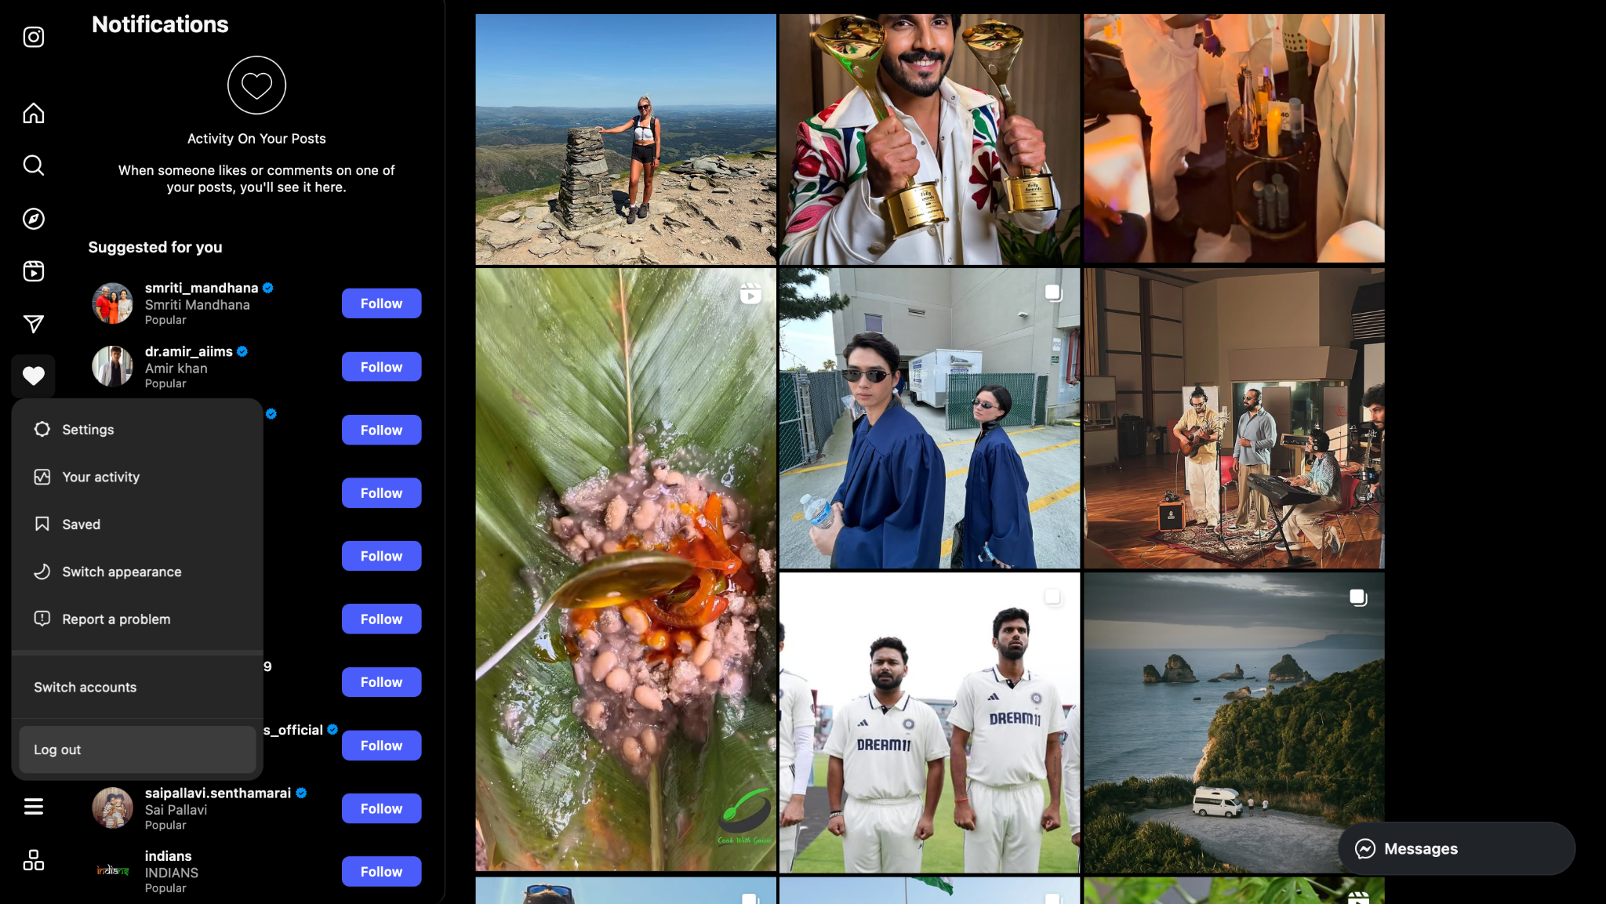*

### **Scenario ID: 3b**

**Scenario:** Logout via Back Button  
**Test Steps:**

1. Login to app
2. Click Logout
3. Press browser back button

**Screenshots:**-

### **Scenario ID: 4a**

**Scenario:** Check Button Alignments  
**Test Steps:**

1. Go to Login Page
2. Observe button placements

**Screenshots:**-

### **Scenario ID: 4b**

**Scenario:** Check Color Contrast in Dark Mode  
**Test Steps:**

1. Enable Dark Mode
2. Navigate through all screens

**Screenshots:***-*

### **Scenario ID: 4c**

**Scenario:** Check Input Field Spacing  
**Test Steps:**

1. Open Register Page
2. Observe spacing between Email and Password fields

**Screenshots:***-*

### **Scenario ID: 4d**

**Scenario:** Visual Feedback on Click  
**Test Steps:**

1. Hover and click on buttons and inputs

**Screenshots:***-*

* **Summary Of Test Results:**

**Total Test Cases-** 22

**Passed-** 20

**Failed-** 2

**Pass %-** 91.67%

### **Conclusion and Recommendations:**

**Pass Rate: 91.67%, Needs Improvement**

### **Issues Found**

1. **Duplicate Email Allowed (1b)**Instagram allowed sign-up using an already registered email, resulting in account creation without any error.
2. **No Login Rate Limiting (2g)**Even after more than 15 failed login attempts with wrong credentials, there was no rate-limiting warning, CAPTCHA, or restriction.

### **Recommendations**

1. **Add Email Uniqueness Check**Prevent duplicate account creation by enforcing unique email validation during sign-up.
2. **Implement Login Rate Limiting**Introduce rate limits and show appropriate warnings (like CAPTCHA or lockout) after multiple failed login attempts.

* **Bug Reports:**

**1.**

| **Field** | **Description** |
| --- | --- |
| **Bug ID** | BUG-1b |
| **Title** | Sign up allows already registered email |
| **Module** | Sign Up |
| **Severity** | High |
| **Steps to Reproduce** | 1. Click on Sign Up 2. Enter existing Email  3. Fill all fields  4. Click on Sign Up |
| **Expected Result** | Should show error that email is already in use |
| **Actual Result** | Account was created successfully |
|  |  |

**2.**

| **Field** | **Description** |
| --- | --- |
| **Bug ID** | BUG-2g |
| **Title** | No rate limit or CAPTCHA on repeated failed login attempts |
| **Module** | Login |
| **Severity** | Medium |
| **Steps to Reproduce** | Try logging in with wrong credentials 20+ times |
| **Expected Result** | Error like “Too many attempts” or CAPTCHA should be shown |
| **Actual Result** | Only password error shown |
|  |  |